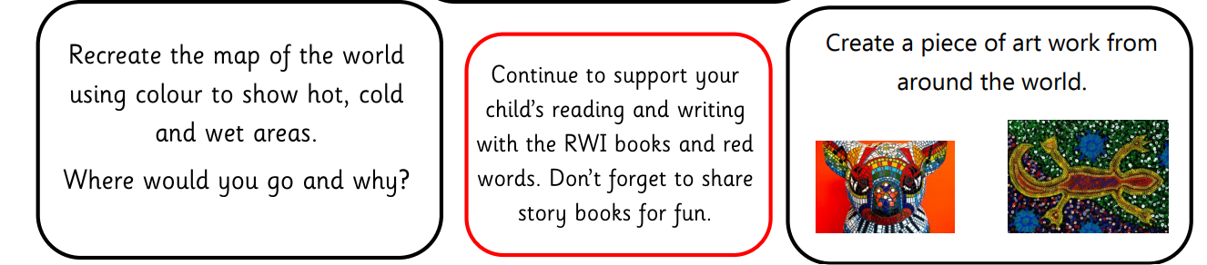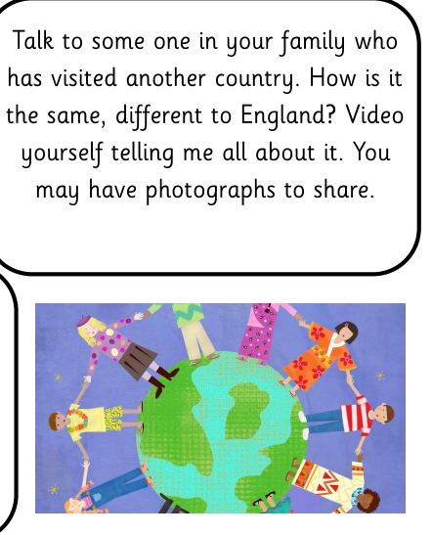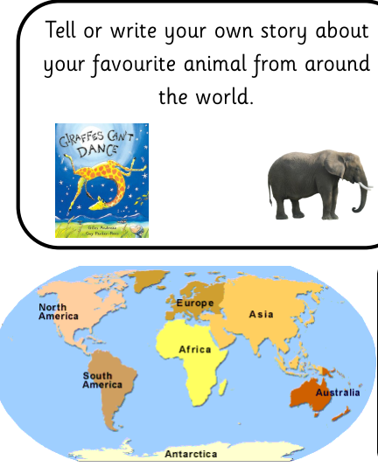

**Park Fell**

**Spring 2 Long term homework**

**Our topic – I wonder what is around the world.**

Please complete 2 pieces by the end of the half term and send via DoJo for us to celebrate.