

It is important that your grant is used effectively and based on school need. The Education Inspection Framework makes clear there will be a focus on ‘whether leaders and those responsible for governors all understand their respective roles and perform these in a way that enhances the effectiveness of the school’.

Under the Quality of Education Ofsted inspectors consider:

Intent - Curriculum design, coverage and appropriateness

Implementation - Curriculum delivery, Teaching (pedagogy) and Assessment

Impact - Attainment and progress

To assist schools with common transferable language this template has been developed to utilise the same three headings which should make your plans easily transferable between working documents.

Schools must use the funding to make additional and sustainable improvements to the quality of Physical Education, School Sport and Physical Activity (PESSPA) they offer. This means that you should use the Primary PE and sport premium to:

• Develop or add to the PESSPA activities that your school already offer

• Build capacity and capability within the school to ensure that improvements made now will benefit pupils joining the school in future years

• The Primary PE and sport premium should not be used to fund capital spend projects; the school’s budget should fund these.

Pleasevisitgov.ukfortherevisedDfEguidanceincludingthe5keyindicatorsacrosswhichschoolsshoulddemonstrate animprovement.Thisdocumentwillhelpyoutoreviewyourprovisionandtoreportyourspend.DfEencouragesschools to use this template as an effective way of meeting the reporting requirements of the Primary PE and Sport Premium.

We recommend you start by reflecting on the impact of current provision and reviewing the previous spend.

Schools are required to publish details of how they spend this funding, including any under-spend from 2021/2022, as well as on the impact it has on pupils’ PE and sport participation and attainment. All funding must be spent by 31st July 2023.

We recommend regularly updating the table and publishing it on your website throughout the year. This evidences your ongoing self-evaluation of how you are using the funding to secure maximum, sustainable impact. Final copy must be posted on your website by the end of the academic year and no later than the 31st July 2023. To see an example of how to complete the table please click HERE. 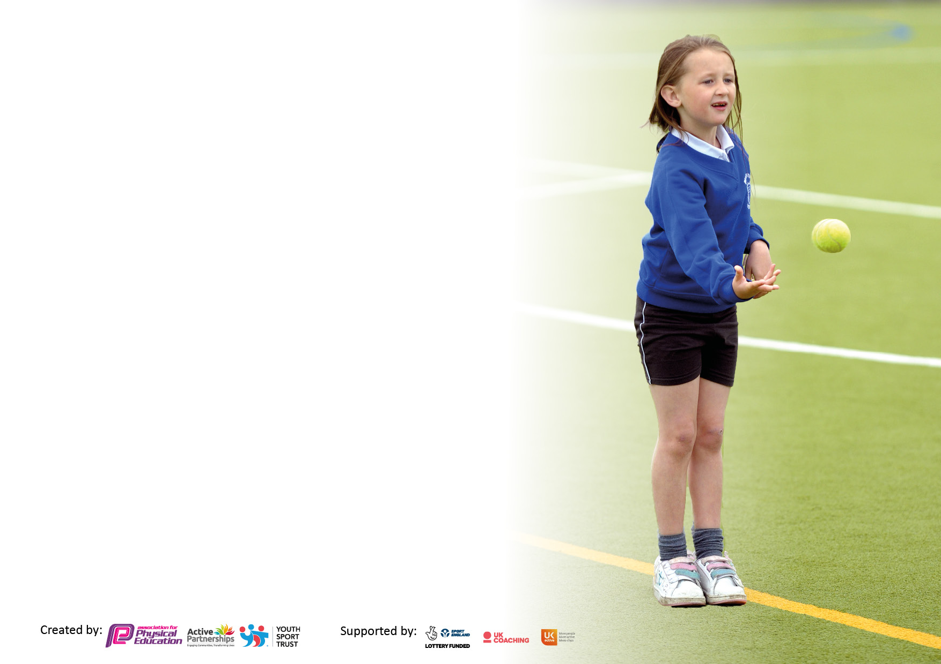

**Details with regard to funding**

Please complete the table below.

|  |  |
| --- | --- |
| Total amount carried over from 2021/22 | £ |
| Total amount allocated for 2022/23 | £ |
| How much (if any) do you intend to carry over from this total fund into 2023/24? | £ |
| Total amount allocated for 2021/22 | £ |
| Total amount of funding for 2022/23. To be spent and reported on by 31st July 2022. | £ |

**Swimming Data**

Please report on your Swimming Data below.

|  |  |
| --- | --- |
| Meeting national curriculum requirements for swimming and water safety.  N.B. Complete this section to your best ability. For example you might have practised safe self-rescue techniques on dry land which you can then transfer to the pool when school swimming restarts.  **Due to exceptional circumstances priority should be given to ensuring that pupils can perform safe self rescue even if they do not fully meet the first two requirements of the NC programme of study** | 100% |
| What percentage of your current Year 6 cohort swim competently, confidently and proficiently over a distance of at least 25 metres?  **N.B.** Even though your pupils may swim in another year please report on their attainment on leaving primary school at the end of the summer term 2021.  Please see note above | 100% |
| What percentage of your current Year 6 cohort use a range of strokes effectively [for example, front crawl, backstroke and breaststroke]?  Please see note above | 100% |
| **What percentage of your current Year 6 cohort perform safe self-rescue in different water-based situations?** | 100% |
| Schools can choose to use the Primary PE and sport premium to provide additional provision for swimming but this must be for activity **over and above** the national curriculum requirements. Have you used it in this way? | No |

**Action Plan and Budget Tracking**

Capture your intended annual spend against the 5 key indicators. Clarify the success criteria and evidence of impact that you intend to measure to evaluate for pupils today and for the future.

|  |  |  |  |  |
| --- | --- | --- | --- | --- |
| **Academic Year:** 2022/23 | **Total fund allocated:** | **Date Updated:** | |  |
| **Key indicator 1:** The engagement of all pupils in regular physical activity – Chief Medical Officers guidelines recommend that primary school pupils undertake at least 30 minutes of physical activity a day in school | | | | Percentage of total allocation: |
| % |
| **Intent** | **Implementation** | | **Impact** |  |
| Your school focus should be clear what you want the pupils to know and be able to do and about  what they need to learn and to  consolidate through practice: | Make sure your actions to achieve are linked to your intentions: | Funding allocated: | Evidence of impact: what do pupils now know and what can they now do? What has changed?: | Sustainability and suggested next steps: |
| Develop their skills in specific sports through accessible school clubs. | Multi-Sport Breakfast club – open to all  Federation wide after school club access  After school club – Girls football  Multi sports | £ | A range of pupils across the school accessed the club and have increased fitness levels and skill mastery within different sports such as football, basketball and other invasion games.  Pupils are more confident in attending clubs and increased team skills. | Create further accessibler opportunities across federation |
| Increase enjoyment of physical activity and access to physical activity during break times.  Have a wide range of equipment available during playtimes  Encourage a love of the outdoors  Mental Health Awareness Week on ‘Why don’t you..?  All children to take part in regular ‘Brain Breaks’ | Playground/sports equipment purchased  Playground markings  Curriculum walks for all KS around local area-produce local area walking booklet(KS2)  Whole school week encouraging exercise, fitness and the benefits of getting outside  Teachers are trained in/supported in  the use of physical activity to enhance learning. New initiatives are included |  | Midday staff use the playground equipment and run activities .Children are beginning to manage these themselves  Pupils are aware of the beautiful local walks available to them and their family. Families have reported going on these walks at weekends.  Discuss their own mental health and the benefits of exercise and being outdoors  Pupils enjoy the wake up sessions. Fitness, behaviour and readiness for learning have all improved. | Maintained and replace of equipment as needed  Marketing of booklet and additions to this.  Ongoing links to be maintained  Develop new and further initiatives. Skipping to be reintroduced as part of ‘Health Heart’ |
| **Key indicator 2:** The profile of PESSPA being raised across the school as a tool for whole school improvement | | | | Percentage of total allocation: |
| % |
| **Intent** | **Implementation** | | **Impact** |  |
| Your school focus should be clear what you want the pupils to know and be able to do and about  what they need to learn and to  consolidate through practice: | Make sure your actions to achieve are linked to your intentions: | Funding allocated: | Evidence of impact: what do pupils now know and what can they now do? What has changed? | Sustainability and suggested next steps: |
| Celebration of sporting accomplishments | .  Celebration of all sporting achievements and events which includes all children. Links to Facebook, Seesaw and certificates. | £ | Children are proud to share and grow in confidence talking about their accomplishments. | Continue next year – develop to share on our website as well. |

|  |  |  |  |  |
| --- | --- | --- | --- | --- |
| **Key indicator 3:** Increased confidence, knowledge and skills of all staff in teaching PE and sport | | | | Percentage of total allocation: |
| % |
| **Intent** | **Implementation** | | **Impact** |  |
| Your school focus should be clear | Make sure your actions to | Funding | Evidence of impact: what do | Sustainability and suggested |
| what you want the pupils to know | achieve are linked to your | allocated: | pupils now know and what | next steps: |
| and be able to do and about | intentions: |  | Can they now do? What has |  |
| what they need to learn and to |  |  | Changed?: |  |
| consolidate through practice: |  |  |  |  |
| Staff’s physical education subject knowledge for their year group is improved through shadowing coaches  Increase resource bank to allow all teachers to enhance subject knowledge. | Feet for Football in school  Time given to staff to shadow  Resources to be purchased and shared between coaches and staff |  | Staff are becoming more confident in their subject knowledge of physical education | Explore further CPD to enhance confidence in teaching of PE with changing staff |
| **Key indicator 4:** Broader experience of a range of sports and activities offered to all pupils | | | | Percentage of total allocation: |
|  |
| **Intent** | **Implementation** | | **Impact** |  |
| Your school focus should be clear | Make sure your actions to | Funding | Evidence of impact: what do | Sustainability and suggested |
| what you want the pupils to know | achieve are linked to your | allocated: | pupils now know and what | next steps: |
| and be able to do and about | intentions: |  | can they now do? What has |  |
| what they need to learn and to |  |  | changed?: |  |
| consolidate through practice: |  |  |  |  |
| Pupils will have the opportunity to travel to engage in new and interesting activities.  For pupils to access OAA above and beyond what they would access in PE lessons. | Pupils travel to Culgaith and surrounding area to work with Action Ants and neighbouring schools to try new and exciting activities  Pupils travel to Weardale Adventure Centre and Eden Outdoors to take part in exciting OAA activates | £ | All pupils have really engaged and enjoyed the session with all pupils having attended half termly sessions. Pupils have tried fencing, archery, cross country running, slacklining, obstacle courses and more!  Team building, confidence and resilience to try rock climbing, canoeing, gorge walking and more | Continue to engage with these sessions and take the pupils to wider events.  Increase and vary the opportunities given-planned residential for all KS2 |

|  |  |  |  |  |
| --- | --- | --- | --- | --- |
| **Key indicator 5:** Increased participation in competitive sport | | | | Percentage of total allocation: |
| % |
| **Intent** | **Implementation** | | **Impact** |  |
| Your school focus should be clear | Make sure your actions to | Funding | Evidence of impact: what do | Sustainability and suggested |
| what you want the pupils to know | achieve are linked to your | allocated: | pupils now know and what | next steps: |
| and be able to do and about | intentions: |  | can they now do? What has |  |
| what they need to learn and to |  |  | changed?: |  |
| consolidate through practice: |  |  |  |  |
| Participate in a wide range of sports competitions/events with other local schools, organised by schools themselves or through Action Ants    Allow all pupils to feel part of a school team and be proud of their participation. | Practise a wide range of sports to prepare children with the necessary skills etc.  Join Action Ants interschool partnership  Contribution to AMF minibus to allow reduced transport costs  Price and purchase T Shirts/Fleeces/sports overalls from Sam Scots with school logo | £ | Pupils have a wider range of skills and feel part of a wider community of schools  All children have access to kits suitable for events | Continue to travel to Action Ants events and to engage with new activities.  Maintenance of kits.  Possible need for further wet weather resources  . |

|  |  |
| --- | --- |
| Signed off by | |
| Head Teacher: | Katherine Bainbridge |
| Date: | 23/6/23 |
| Subject Leader: | Katherine Bainbridge |
| Date: | 23/6/23 |
| Governor: |  |
| Date: |  |