

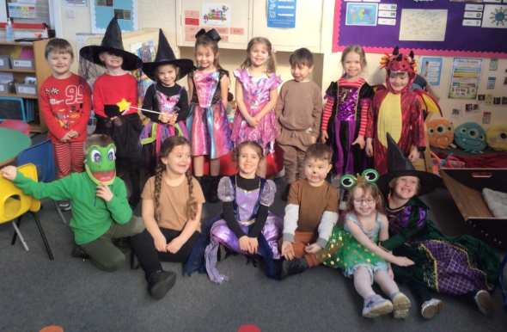
Welcome to Park Fell (Reception class)
We are excited to welcome your children into their first year of school!
Below, I have information about the school and what your child will be getting up to in Reception.

General information:
- School day 8:40-3:25. The classroom doors are open between 8:40 and 8:50 for your arrival. Enter through the Park Fell outdoor area.
- Breakfast club 8:00-8.40 (adults must book a place 24h prior to attending, there is a charge of £2 per session)
- Wraparound is available until 5:30. This must be booked prior to staying. More information on how to book to follow.
- School dinners can be ordered (details of how will follow when available) and are currently free for all reception/KS1 children. Packed lunches should be clearly labelled with name (no fizzy pop or sweets. We also have a no nut policy due to allergies in school). If you are unsure whether your child will like school dinners, you are more than welcome to order a school dinner and bring a packed lunch.
- Please bring a named water bottle in each day.

- Fruit will be provided as a morning snack for every child in reception along with milk. We know that some children like to graze, so we are happy for you to pack extra snacks in their bag for them to eat throughout the day.
- The class teacher is Miss Philipson with Mrs Collins also in class as teaching assistant.

Uniform:
- Uniform – School burgundy jumper (doesn’t need the logo if preferred) , white polo shirt, black or grey trousers/skirt/dress, black school shoes.
- PE kits – black shorts, tracksuit bottoms, jumper/zip up top and a white t shirt. Trainers or pimsolls. Please add a spare pair of socks.
- All uniform and bags need to be clearly labelled with names please.
- It is useful to keep a spare set of clothes in school bags in case of any accidents/water play etc.

Your child’s learning journey:
- We spend the first few weeks getting to know each child and setting a baseline as to where they are in their learning and development so we know our next steps.
- We use the online platform Tapestry to document some of your child’s accomplishments, look out for an email to transfer accounts from Pre-school, or set up new ones.
- We will also share school information and share daily photos of what we have been up to on ClassDojo. A login is in your pack. It is a great way of communicating with each other too so once you are logged in and set up, you can message me with any questions you may have.

Transition sessions:
- I have visits coming up to visit children in their settings after half term.
- I have two dates available for children to visit the classroom for an hour each. If your child is not in pre-school/Gilderdale you are welcome to drop them off for the sessions. (9:15am – 10:15am, Wednesday 17th June and/or Wednesday 24th June).
- Following this, there will be home visits taking place on Monday 29th June and Tuesday 30th June. This gives us a chance to see the children in their own spaces, and means we can have a catch up to talk about any questions you may have about your child starting Reception.

First week:
- Children will begin with full days on Tuesday 1st September.
- I will eat lunch with the children to begin with and be on hand to support lunch time and break times.
- We use this time to build relationships, explore the area and establish routines.

Topics:
Throughout the year we enjoy a range of activities based on a theme.
These topics are:
- All about me
- Celebrations
- Transport
- I wonder what is around the world
- I wonder how things grow
- The seaside
Within these topics, we use the children’s interests to direct the learning and progress each area of development.
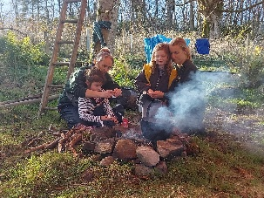
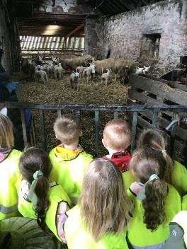
We go on different visits based on these topics such as local walks, forest school at Gilderdale, a farm visit, and a trip to the seaside.

Learning in Reception:
- The Early Years Framework is made up of 7 areas of learning which are accessible through play and directed activities.
These are:
-Communication and language
-Personal, social and emotional development
-Physical development
-Literacy
-Mathematics
-Understanding the world
-Expressive arts and design
It is these areas which shape the learning in Park Fell.
Through in the moment observations and interactions and targeted sessions we will support children in new learning.
We know all children are unique and may move at different paces, we support all children and make the learning accessible for them.
- Playing and exploring, active learning and creating and thinking critically are characteristics of effective learning.
- We look at the ways in which children engage with other people and their environment, we support the learning and development across all areas which enable children to build a secure foundation for future learning.

We have split these areas of development further…

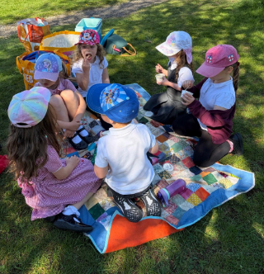
Communicate:
- Speaking
- Back and forth interactions
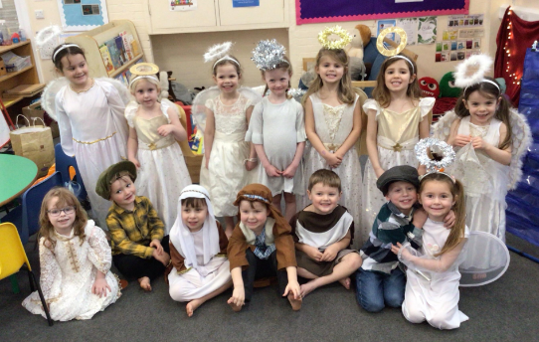
- Listening
- Reading stories
- New vocabulary
- Show and Tell
- Role play

How can you help?
- Reading books (stories, information books, newspapers, magazines, comics etc), encouraging your child to join in and talk about books
- Singing songs and nursery rhymes
- Taking time to listen to them talking about things they’ve done and answering their questions. Allow pause time for them to think of their response.
- Encourage them to use talk to link their ideas and knowledge.

Care:
This is a prime area which is found in all areas and aspects of children’s time in Park Fell. Three parts - self regulation, managing self and making relationships. It is vital that children lead happy healthy lives so there is a focus on children knowing about their physical and mental wellbeing and how they can improve it.
We develop strong, warm and supportive relationships with the children which enables children to learn about their feelings and of those around them.
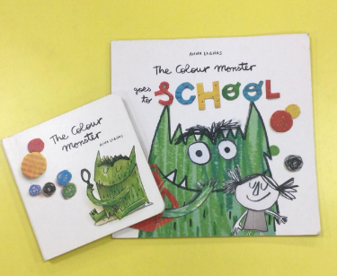
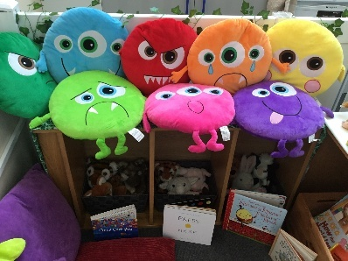
- Making friends
- Learning and understanding rules
- Learning and understanding daily routines
- Understanding boundaries
- Making relationships with adults
- Knowing emotion names, what they mean and how that may make us feel.

How can you help?
- Have rules and routines at home e.g. bedtime routine, rules around time watching TV.
- You can help by encouraging your child to use the toilet independently, wash their hands, brushing teeth, put on and fasten their coats.
- Playing games which encourage sharing and turn taking will help your child to build their social skills.
- Talking about feelings and how you show them.

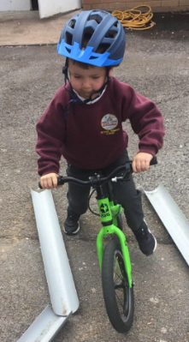
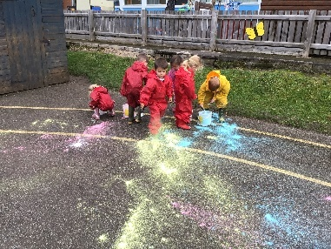
Move:
- Gross and fine motor skills
- Mark making
- Shoes and coats
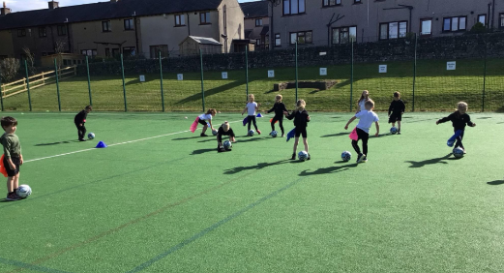
- PE – getting changed too!
- Dance
- Outdoor area
- Pencil control

How can you help?
- Give children time to run, jump, climb, bike and play outdoors
- Encourage children in activities such as building, drawing, threading beads,
or filling and emptying containers in the water – all of which develop manipulative skills.
- Praise the effort rather than outcome, make children confident to ‘have a go’.
Give children time to run, jump, climb, bike and play outdoors
- Encourage children in activities such as building, drawing, threading beads,
or filling and emptying containers in the water – all of which develop manipulative skills.

Read and write:
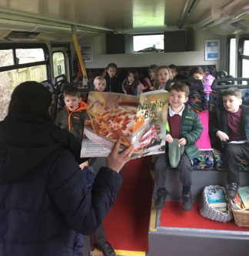
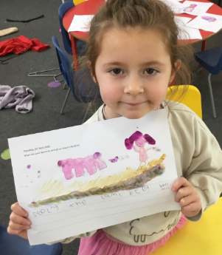
- Recognising and writing their name and simple words (when ready)
- Phonics – Read Write Inc.
- Sharing and joining in with stories, rhymes, songs and poems
- Writing
How can you help?
- Share stories – read to your child and allow them to make their own story using the pictures
- Encourage recognition of their name and other familiar words (shop names, food packets etc)
- Allow your child to see you writing (shopping lists, notes, emails etc)
- Have pens, pencils and paper available for mark making. Talk to your child about what they’ve written. Praise every effort.
- Allow time to practice the RWI sound cards/words/reading (when they get to that stage).

Count:
We take time to develop a deep understanding of numbers to 10 using practical activities – how they are made, patterns between them etc, to ensure children have a strong base of knowledge for future learning.
- Counting
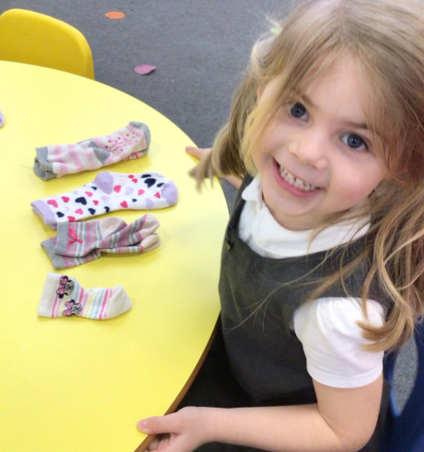
- Recognising numerals and what they mean (how many)
- Composition (add, take away, group and sharing)
- Pattern
- Comparison (more, fewer)
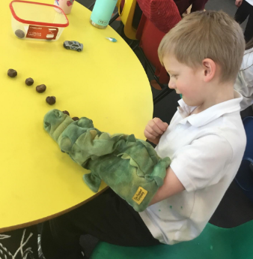
- Problem solving
- Subitising small groups
- Shapes
- Measurement

How can you help?
- Singing counting songs and rhymes
- Counting, adding and subtracting anything and everything - socks, cars, shopping, cutlery, fingers and toes!
- Pointing out numerals all around
- Encourage problem solving
- Practise numeral recognition and 1:1 correspondence
- Subitise amounts

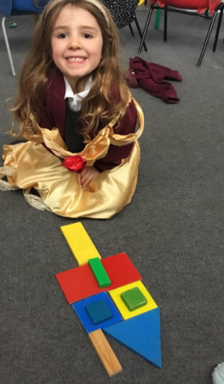
Explore:
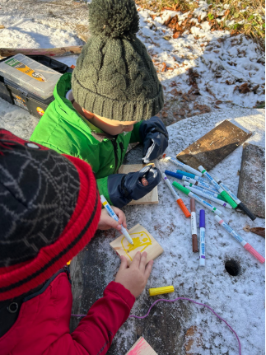
- Exploring new and old things
- Investigating
- Learning about other cultures, places, living things and things that happened in the past
- Constructing
- Educational visits
- Outdoor area
- Forest School

How can you help?
- Talk with your child about the places they go and things they see in the world around them
- Answering and asking questions - What if…? Why do you think…? How did you…?
- Letting children join in with everyday activities - washing up, cooking, shopping, helping in the garden...
- Visit new places and make comparisons between where you live and there.
- Talk about how things were in the past

Create:
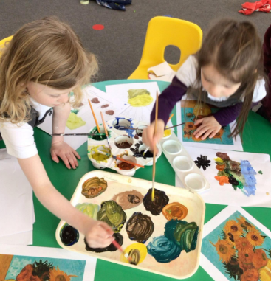
- Role play
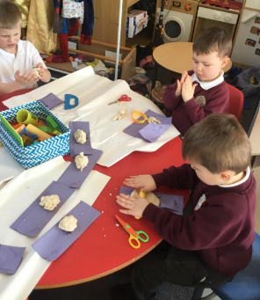
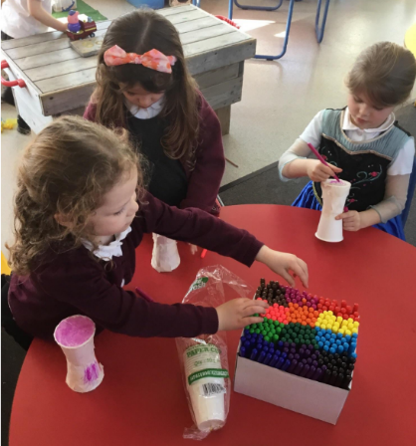
- Art
- Painting
- Drawing
- Dance
- Music
- Singing
- Story
- Imagination

How you can help?
- Talk with your child about their imaginative play and
join in if possible!
- Encourage them to be flexible in their thinking and use of materials and praising them for their efforts or ideas, as well as the end product. Remember our perfect is different to a child’s.
- Discuss how materials look and feel.
- Show that it is okay when things don’t go to plan. Problem solve together how to improve it.

