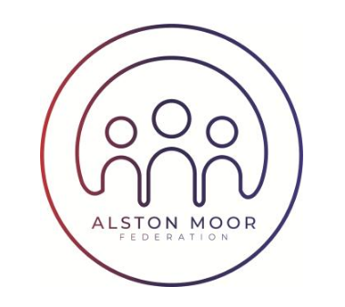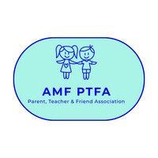

**Working Together – Achievement For All**

3rd September 2025

Dear Parent/Carer,

Hello from AMF Parent Teacher and Friend Association (PTFA)!

Welcome to the new term at AMF – we are very excited for the next round of fundraising and activities.

**Save the Date! Friday 7th November** will be our annual Lantern Procession, Bonfire and Fireworks Display. Last year you all rallied round and we had an amazing night, raised lots of money and we hope for the same again this year.

We will be scheduling in workshops for APS and NPS to make masks and lanterns in October, so watch out for dates and send your kids in to make some more amazing creations. If you could help out at a workshop (after school for 1 hour max, no training required!) please let us know at [amfpta@alston.cumbria.sch.uk](mailto:amfpta@alston.cumbria.sch.uk).

We are also very excited to be supporting Nick Bazley on a Christmas Panto ‘The Pied Piper of Alston’, which will be performed at Alston Town Hall on Friday 2nd and Saturday 3rd January, with proceeds going to the PTFA.   
  
Rehearsals start on Monday 8th September, no experience necessary – but if your children and/or you would like to be involved, please see the attached poster.

We also attach our volunteer letter sent out last term. If you can volunteer to help out the PTFA in any way, we’d be really grateful.

We hope to hear from you soon,

Glayne Burdon, Ian Taylor-Lynch, Amy Carrick, Sarah Stamford, Jackie Edgar and Stacy Towler

Hello from AMF Parent Teacher and Friend Association (PTFA)!

We are a small group of parents who come together to raise funds, to support the schools of Alston Moor.

We’re really proud of what we’ve been able to provide for our schools in the past year:

* Funding for NPS school trips
* Funding for the school Learning Bus
* Workshops for Lanterns and Masks
* Books from Santa for APS and NPS
* Christmas Crackers
* Westmorland & Furness Grant for AMF Choir
* Funding for theatre visits

All of this is done through our events and fundraisers, which are enjoyed across the Moor. The events/fundraisers we’ve put on this year include:

* Annual Duck Race & BBQ
* Annual Bonfire, Fireworks and Lantern/Mask procession
* Annual Sunflower growing competition
* Annual Cake sale/Plate Smash at the Gala
* Santa visit with presents for APS and NPS
* Valentine’s Disco
* May Disco
* Plate Smash at the Fairhill May Fair
* Hexham Races day out

For a small group, we do a lot. But we’d like to do more!

Do you think you could help? We would really welcome a few more pairs of hands!

Could you:

* Bake a cake or biscuits for events?
* Help out at events?
* Come and help out for an hour running a stall?
* Jump in the river for the Duck Race?
* Wrap Christmas presents?
* Design a poster?
* Help write a grant application?

Or, could you join the committee and help us organise the fundraising events? We’re a friendly bunch! We only meet once a month on a Thursday evening, usually around 8pm, via Zoom. Meetings usually last about 1 hour.

We understand how busy you are – us too! We are all full-time workers and juggle volunteering alongside life, work and kids.

Anything you could do, large or small, would be really appreciated. The more help we get, the more we can do to raise funds for our schools. As a Friends Association, we are not just limited to people who have children in the schools, we’re open to friends, extended family, ex-pupils and their families. Please feel free to pass this letter on.

If you think you could help, please contact us:

* Email [amfpta@alston.cumbria.sch.uk](mailto:amfpta@alston.cumbria.sch.uk)
* Message us on Facebook <https://www.facebook.com/groups/307315329632869/>

We hope to hear from you soon,

Glayne Burdon, Ian Taylor-Lynch, Amy Carrick, Sarah Stamford, Jackie Edgar and Stacy Towler