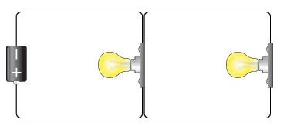

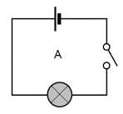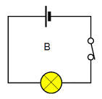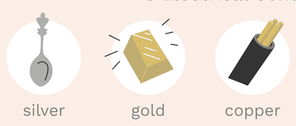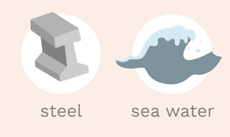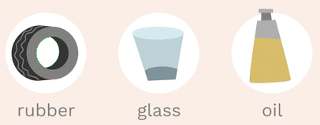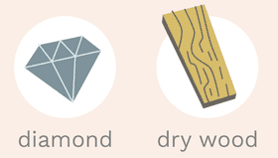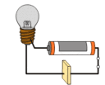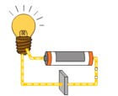

Electrical Conductor

Electrical Insulator

VS

In contrast, insulators are Conductors are materials materials that impede (do that permit electrons to not allow) the free flow of flow freely from particle electrons from atom to to particle. They can be atom and molecule to used to make a switch. molecule. They can be

used to make a plug or wire cover.

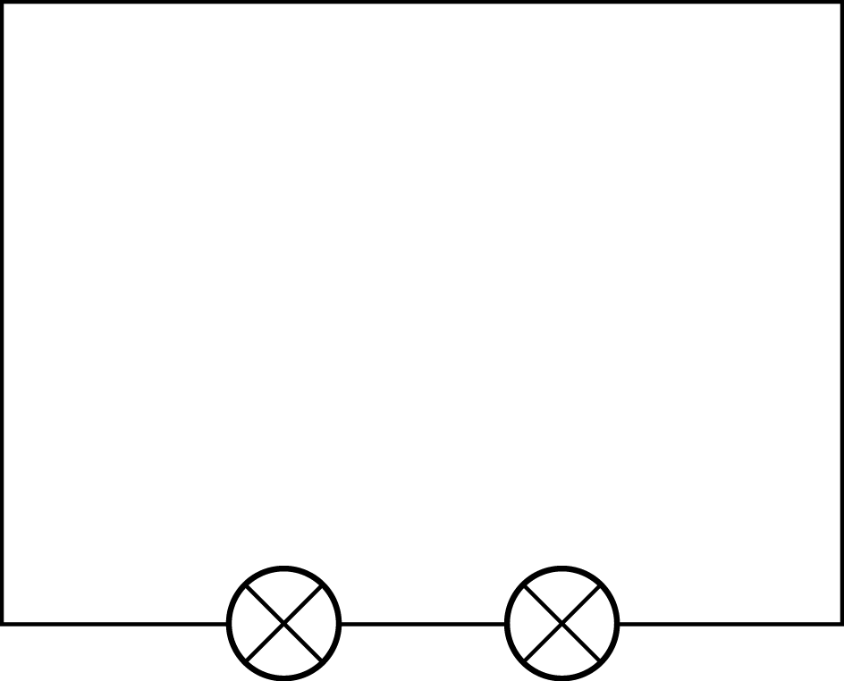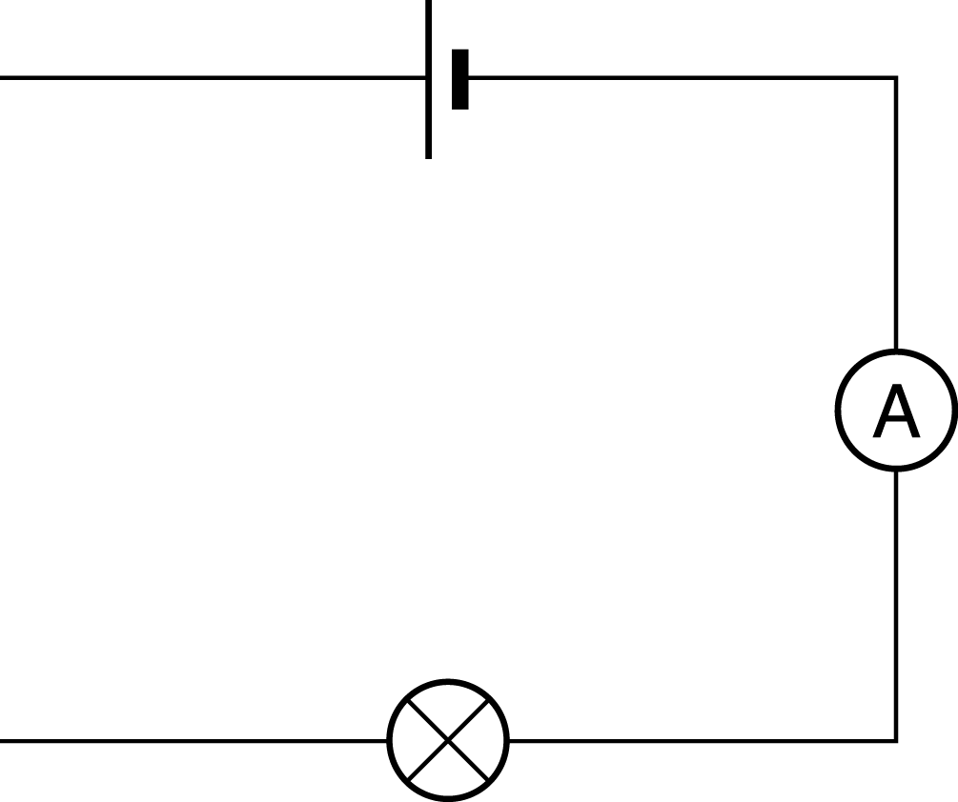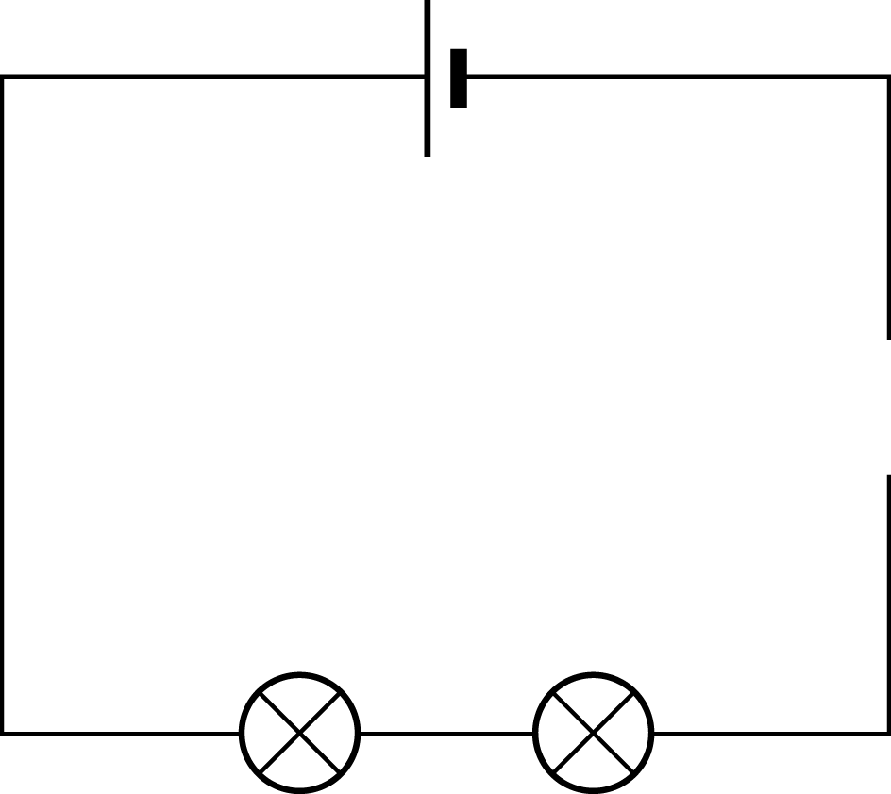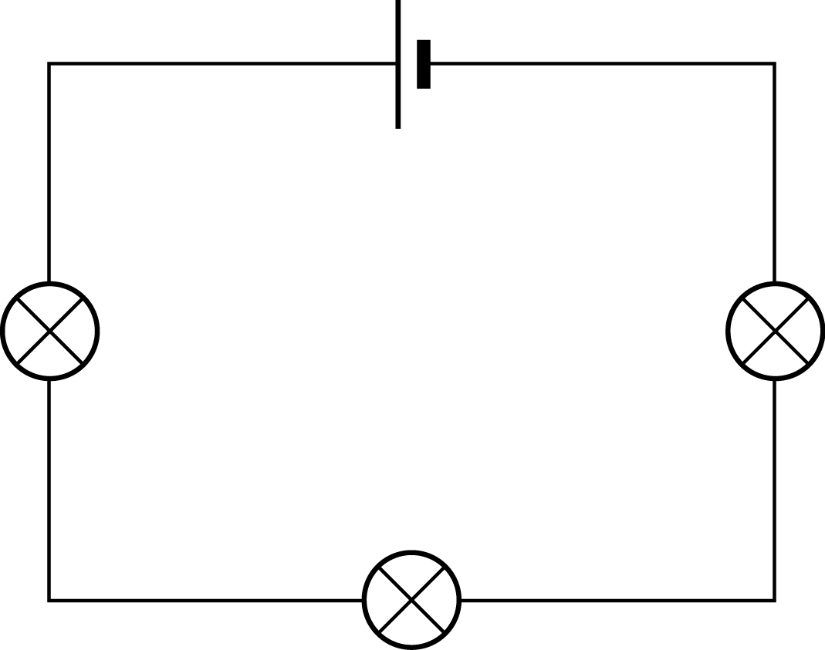

1. Circuits need power (usually battery or batteries)
2. Circuit must not have any breaks
3. Switch must be on and creating a complete circuit to work
4. For bulbs to light brightly, they must have enough power.

**Faults in a Circuit**

|  |  |
| --- | --- |
| **Knowledge - Series and Parallel Circuits** | |
| There are two types of circuit we can make, called series and parallel. The components in a circuit are joined by wires. If there are no branches then it's a series circuit. If there are branches it's a parallel circuit. | |
| 1. Components connected in series are connected along a single conductive path. 2. The same current flows through all of the components but voltage is dropped (lost) across each of the resistances. 3. In a series circuit, every device must function for the circuit to be complete. If one bulb burns out in a series circuit, the entire circuit is broken.. | 1. In a series circuit, the sum of the voltages consumed by each individual resistance is equal to the source voltage. 2. Components connected in parallel are connected along multiple paths so that the current can split up; the same voltage is applied to each component. 3. In parallel circuits, each light bulb has its own circuit, so all but one light could be burned out, and the last one will still function. |

|  |  |
| --- | --- |
| **Vocabulary** | |
| 1. Ammeter | Measures the current in a circuit. |
| 2. Appliances | A device or machine in your home that you use to do a job such as cleaning or cooking. Appliances are often electrical. |
| 3. Battery | Made up of one or more cells. |
| 4. Electron | Particle with a charge of negative electricity, found in all atoms and acting as the primary carrier of electricity in solids. |
| 5. Proton | A particle occurring in all atomic nuclei, with a positive electric charge. |
| 6. Cell | A synonym for a single battery. |
| 7. Circuit | A complete route which an electric current can flow around. |
| 8. Component | The parts of which something is made. |
| 9. Conductor | A substance that heat or electricity can pass through or along. |
| 10. Current | A flow of electricity through a wire or circuit. |
| 11. Device | An object that has been invented for a particular purpose. |
| 12. Electricity | A form of energy that can be carried by wires and is used for heating and lighting, and to provide power for devices. |
| 13. Insulator | A non-conductor of electricity or heat. |
| 14. Mains | Where the supply of water, electricity, or gas enters a building. |
| 15. Motor | A device that uses electricity or fuel to produce movement. |
| 16. Resistance | A force which slows down a moving object or vehicle. |
| 17. Resistor | A part of an electric circuit that provides resistance to some of the current. |
| 18. Switch | A small control for an electrical device which you use to turn the device on or off. |
| 19. Voltage | The force of an electric current as measured in volts. |
| 20. Series Circuit | A series circuit is a closed circuit in which the current follows one path. |
| 21. Parallel Circuit | Closed circuit in which the current divides in two or more paths before rejoining. |

|  |  |
| --- | --- |
| **Switches** | |
| 1. When a switch is open (off) there is a gap in the circuit. 2. Electricity cannot flow around the circuit. |  |
| 1. When a switch is closed (on) it makes the circuit complete. 2. Electricity can flow around the circuit. |  |

|  |  |
| --- | --- |
| **Knowledge - What Effects a Circuit** | |
| What will make a bulb brighter or a buzzer louder?   1. More batteries or a higher voltage create more power to flow through the circuit. 2. Shortening the wires means the electrons have less resistance to flow through. | What will make a bulb dimmer or a buzzer quieter?   1. Fewer batteries or a lower voltage give less power to the circuit. 2. More buzzers or bulbs mean the power is shared by more components. 3. Lengthening the wires means the electrons have to travel through more resistance. |

***UKS2 Science Knowledge Organiser - Electricity***

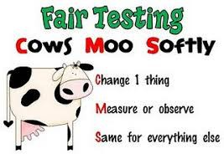

|  |
| --- |
| **By the end of the topic on electricity, students should be able to**:   1. - Understand the basic principles of electricity, including current, voltage, and resistance. 2. - Identify and describe the difference between series and parallel circuits. 3. - Construct simple electric circuits using batteries, wires, and bulbs. 4. - Recognise conductors and insulators and their roles in electrical circuits. 5. - Explain how switches control the flow of electricity. 6. - Understand the importance of electricity in everyday life, including safe usage and energy conservation. 7. - Develop skills in scientific inquiry through experimentation with circuits and electrical components. |
| **Experiment Steps to Success - Fair Testing** |
| A fair test is a test which controls all but one variable when attempting to answer a scientific question. Only changing one variable allows the person conducting the test to know that no other variable has affected the results of the test.  To help remember how to conduct your fair test, learn the mnemonic:  For example, testing how quickly three items - marshmallow, chocolate and wax - melt over time.  **Change 1 thing:** the item you are melting **Measure or observe:** melting / temperature **Same for everything else:** heating, beaker, size of item, thermometer |

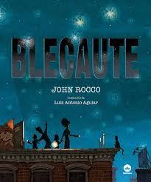

These stories help you to gain a greater understanding of electricity and may spark some questions that you might want to ask in your next science lesson!

Hitler’s Canary by Sandi Toksvig

Goodnight Mister Tom by Michelle Magorian Blackout by John Rocco

Stories that relate to the topic of Electricity’ are:

**Literacy links to this topic**

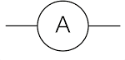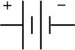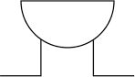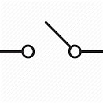

4)

1)

Lumens recorded with number of batteries.

2)

5)

Data tables help you keep information organised. If you're collecting data from an experiment or scientific research, saving it in a table will make it easier to look up later.

1. Name your table - make sure the title relates to the data you will put in your table
2. Decide how many columns and rows you need.
3. Draw the table. Using a ruler, draw a large box and making the necessary number of columns and rows.
4. Label all your columns.
5. Record the data from your experiment or research in the appropriate columns.

**Creating a Data Table**

|  |  |
| --- | --- |
| **Key Concepts and what they mean** | |
| 1. Physics | Physics is the study of energy and matter in space and time and how they are related to each other. |
| 2. Chemistry | Chemistry deals with the properties of substances, the transformations they undergo, and the energy that is released or absorbed during these processes. For example, when plants use sunlight to produce energy (or food for itself). |
| 3. Data Collection | Data collection is the process of gathering and measuring information to answer a question. For example, recording living and non living things to investigate whether numbers change depending on the weather. |
| 4. Cause and effect | Cause and effect is the relationship between events or things, where one is the result of the other or others. For example, the weather gets colder and there is less food around, so animals hibernate. |
| 5. Envrionmental | Environmental relates to the environment around us at Old Fletton. |

|  |  |  |  |
| --- | --- | --- | --- |
| **Circuit Symbols** | | | |
|  | Switch Closed |  | Cell |
|  | Ammeter |  | Motor |
|  | Battery |  | Resister |
|  | Bulb |  | Switch Open |
|  | Buzzer |  |  |

|  |  |
| --- | --- |
| Number of batteries | Lumens |
| 1 | 23 |
| 2 | 34 |
| 3 | 45 |
| 4 | 0 |

**Year 6 Science Skills Knowledge Organiser - Electricity**