Cross Fell
Spring welcome letter January 2024
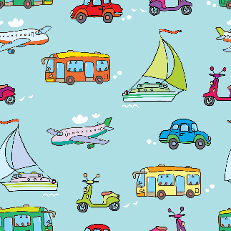

Welcome Back! We hope you have had a lovely time over the Christmas break and are now ready to start the new year refreshed! We are looking forward to getting started with our new topic which is machines and journeys.
As last term Miss Philipson will teach each Monday and Tuesday and Mrs Brown will teach Wednesday, Thursday and Friday. They will be supported by Miss Culshaw every day and Mrs Liverick each morning.
Topic
Our topic this half term is machines and journeys where in Geography we will travel around the world, learning about the 5 continents and 7 oceans. In History we will learn about journeys from the past including travelling by train and into space, in Science we will learn about a range of materials and test materials to see which is most suitable for a range of uses including a ramp experimenting testing how far we can drive some toy cars. In Art we will be learning about the artist Paul Klee as well as doing some transport themed printing and DT we will be designing and then making our own vehicles which promises to be excellent fun!
A jam-packed topic with lots of exciting learning and we can’t wait to get started!

General reminders
Just a polite reminder to say that we have 26 children in our class and so labelling of all clothing and belongings is extremely helpful so that we can return any misplaced items.

We will be using our outdoor space so please ensure your child has a warm coat with them each day (that is labelled with their name please).

Our classroom is a busy space this year and our peg area is quite full. Please can we ask that children only bring essential items in from home.

We are finding that quite often the children do not have their reading records and books in school which makes things tricky when we are trying to do our group reading sessions so please can we ask that each day your child brings their book bag with reading book and record, as well as a coat and named water bottle which contains only water please.
Please do not send rucksacks, any toys or pencil cases into school.

Fruit will be available daily but children will need to bring in their own named water bottle. We will send these home each day to be washed and refilled.

Door open at 8.40 am and our first session of the day starts at 8.50am. At this time our classroom door will be closed so that we can start our lessons. If you arrive after this please come in via the office/front entrance on Church Road so that the children can be added to the register.

PE
PE will be on the same days, Tuesdays and Wednesdays, with sessions led by Miss Philipson on a Tuesday and NUFC on a Wednesday. Children will come to school in uniform on a Tuesday, bringing PE kits with them to get changed after lunch. On a Wednesday, children can come in their kits and stay in them all day. Pe kits are joggers, a plain white t-shirt, plain black jumper/hoodie and trainers. If there is any change, we will let you know on DoJo.

School dinners
To save lost learning time in school please can school dinners be ordered at home in advance, staff in the main office will be able to provide password reminders in order to log in at home if required.
Homework
Thank you for all of the support you give with homework especially with reading- it really makes a huge difference to the children’s progress please remember to write regular comments in reading diaries so that we can award Dojos each week.
As with last year Read, Write, Inc. (RWI) homework and reading books are given out each week. These books are to celebrate success and your child should be able to read them to you fluently. We have a limited number of each book so please make sure they are returned to school each week. The books will be checked in/out using our library system. Any lost books will be charged for.
Children have a login for Numbots where they can play fun games to help them to build speed and fluency in maths. Login details are stuck onto the front of Reading Record books.
The long-term topic homework has been posted onto Class Dojo and sent out in book bags. Each activity is set up in your child’s portfolio online so that they can respond to it online and we can share it on the big screen in class.
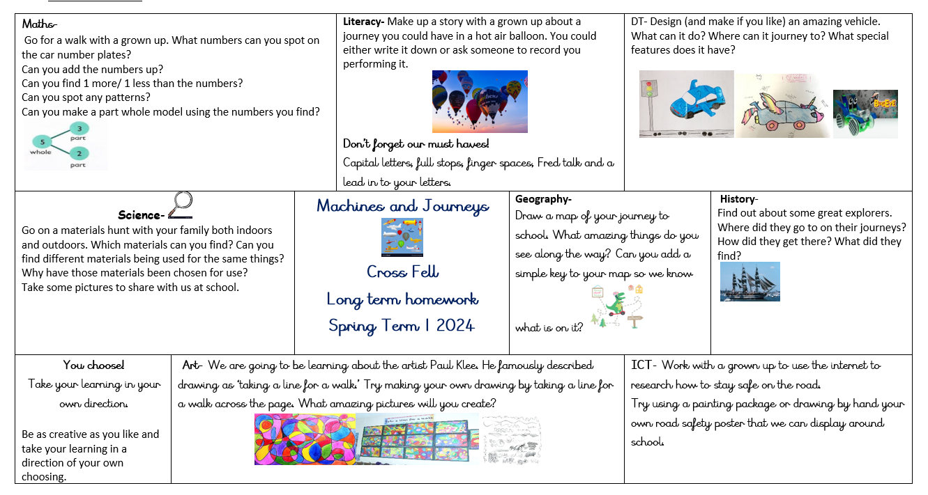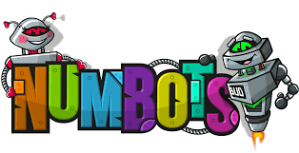
Help needed
During the week of the 22nd January all of the children will begin to make their own vehicles using junk modelling boxes so please could you start collecting and then send into school in a named carrier bag a selection of empty boxes that your child can use to make their vehicle.
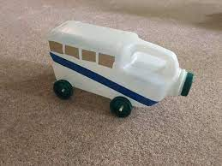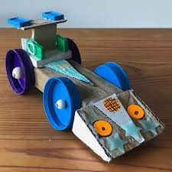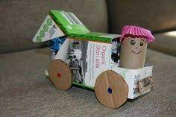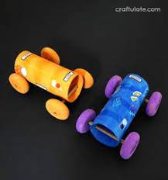

If you have any questions please contact us via Class Dojo or the school office and we will get back to you as soon as we can.

We are really looking forward to continuing your child’s learning journey with them this year and can’t wait to get started.

Miss Philipson and Mrs Brown

