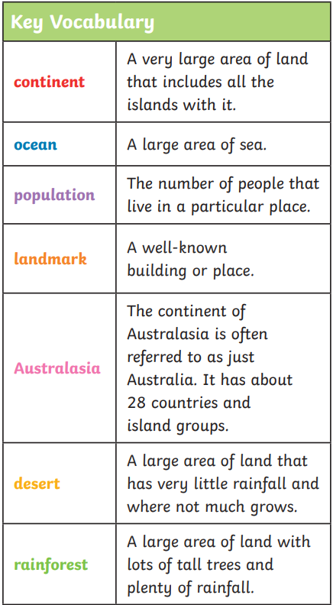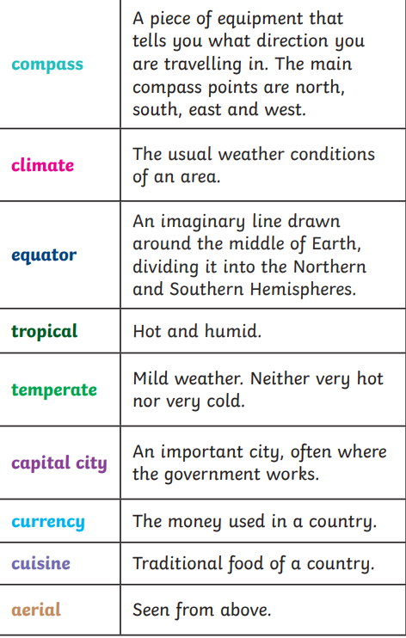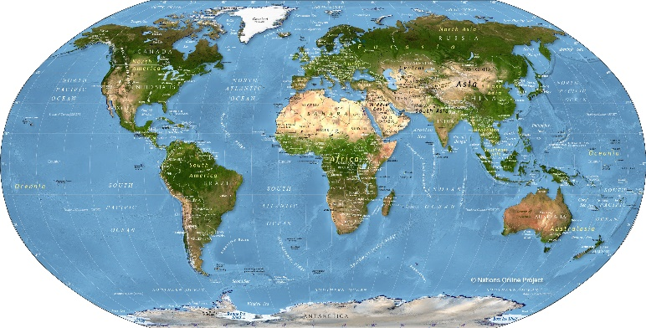**Topic - What a wonderful World – Cross Fell**

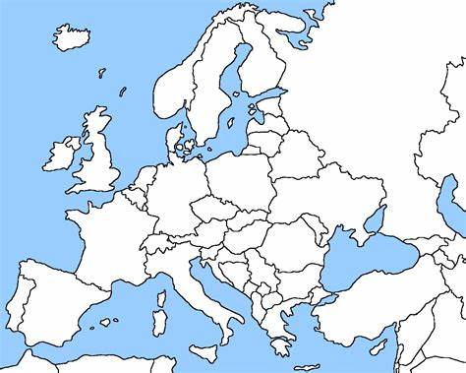

There are 7 continents which are Africa, Antarctica, Asia, Australasia, Europe, North America, and South America.

We live in Europe which is the second smallest continent and has around 44 countries.

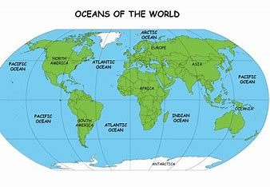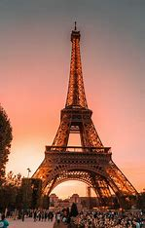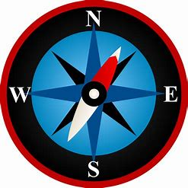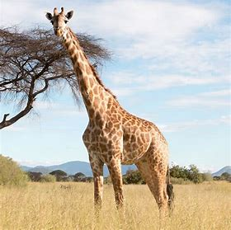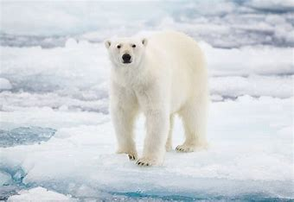

Landmarks:

We are looking at aerial photos of places and landmarks. Some of these are natural and some of these are man-made (made by humans).

We are also looking at natural features around the world which include lakes, caves, forests, mountains, and cliffs. As well as this we will look at man-made features such as bridges, buildings and roads.

There are 5 oceans which are Arctic, Atlantic, Indian, Pacific and Southern.

We use a compass to plan routes or describe where we are using North, East, South, West.

There are different climates around the world. There are warm, cold (or polar), tropical, and temperate. Countries near the equator have a hotter climate and different animals live in different climates.