Why is Art important?
Art education provides an essential contribution to the creativity, culture, wealth and well-being of the nation.
Inspiring a new generation of designers, makers and artisans.
This is a vibrant and dynamic course, that aims to give you the freedom to explore art in ways that inspire and bring out the best in you, whilst equipping you with a range of skills desired by employers or when continuing to study the subject confidently at AS, A-level and beyond. This creative subject will support your ability to become problem solvers, innovative explorers, imaginative, independent, decision makers, reflective learners, risk takers, creative and critical thinkers which are essential qualities in the world of work.
What is the aim of the KS3 Art curriculum at SKS?

At Samuel King’s School we engage, inspire and challenge pupils, equipping them with the knowledge and skills to experiment, invent and create their own works of art, craft and design.
During their time in the art and design department pupils will be encouraged to work with a wide range of mediums, taking creative risks without fear, allowing them to build their confidence and realise their thoughts and ideas more fully. We believe in order to make excellent progress pupils are required to expand skills year on year to embed creative language through art.

At Key Stage 3 our curriculum is designed to stretch pupils, allowing them to explore a wider range of creative processes. Focus is on supporting pupils to develop knowledge of the formal elements of art and understand how to communicate these within their own work.
Pupils will begin to build a more robust knowledge of great artists and art movements, to understand the historical and cultural context of their art forms.

How is the Art curriculum structured at SKS?
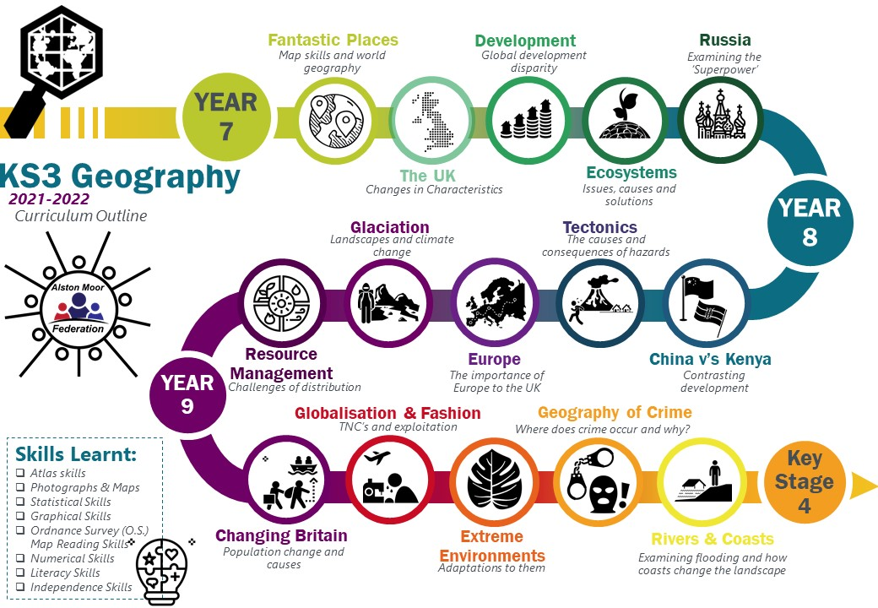

Drawing

Culture

Colour
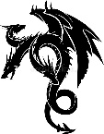
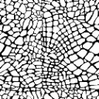
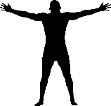
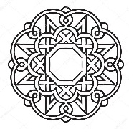
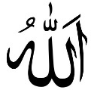
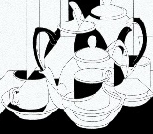
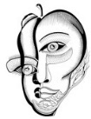
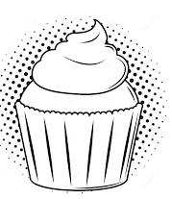
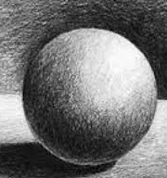
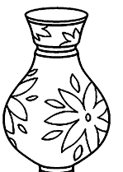
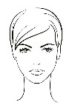
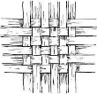
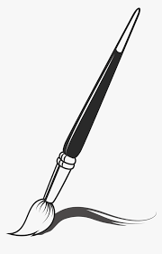
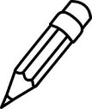
3D Sculpture

Drawing texture

Oil pastels Cubism
Culture
Myths and Legends
Pencil/ Pastels Shape, tone, form, proportion
KS3 Art, Craft and Design

- Observation skills
- Drawing Skills
- Painting Skills
- Mark Making Skills
- Presentation Skills
- Reflective skills
- Independence Skills
- Literacy Skills
Clay Islamic tiles

Portraiture
Mixed media Dadaism/surrealism
Paint Contrast, ratio
Papier Mache Pop Art

Food
PatternWeave, tessellation
Human form
Still Life

