Why is DT important?
Design and technology education provides an essential contribution to the creativity, culture, wealth and
well-being of the nation. Inspiring a new generation of designers, manufacturers, engineers and artisans. You will develop good practical skills with an eye for detail and quality, through learning a range of skills desired by employers or when continuing the subject confidently at AS, A-level and beyond. Design Technology can lead to inspiring careers within the world of innovation, technology and design.
This creative subject will support your ability to become problem solvers, innovative explorers, imaginative, independent, decision makers, reflective learners, risk takers, creative and critical thinkers which are desirable whichever pathway you take.
What is the aim of the KS3 DT curriculum at SKS?
Design and technology at Samuel King’s is an inspiring, rigorous and practical subject. Pupils use their creativity and imagination to design and make products that solve real and relevant problems within a variety of contexts, considering their own and others’ needs wants and values.
The broad range of subject knowledge draws on disciplines such as mathematics, science, engineering, computing and art.

We strongly believe in the importance of taking ‘creative’ risks, thus enabling pupils to become resilient, resourceful problem solvers, innovative, enterprising and capable citizens. Our aim is to encourage pupils to be confident reflective learners, able to explore and develop their ideas fully.
Through the evaluation of past and present design and technology, pupils develop a critical understanding of its impact on daily life and the wider world. Our curriculum is designed to enthuse and inspire pupils through the broad and ambitious creative opportunities we offer.
In order to make excellent progress pupils are required to build skills year on year to embed knowledge and understanding of the breadth of disciplines within. It is important that pupils are challenged across all 4 core principles in the design technology department, which include design, make, evaluate and to build technical knowledge.
How is the DT curriculum structured at SKS?
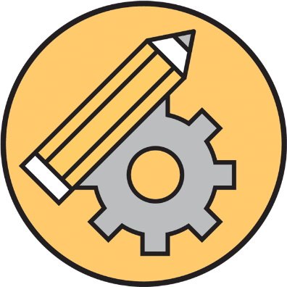

Electronics Graphics
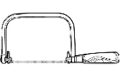
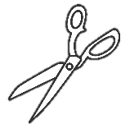
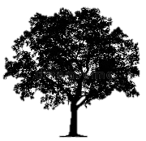
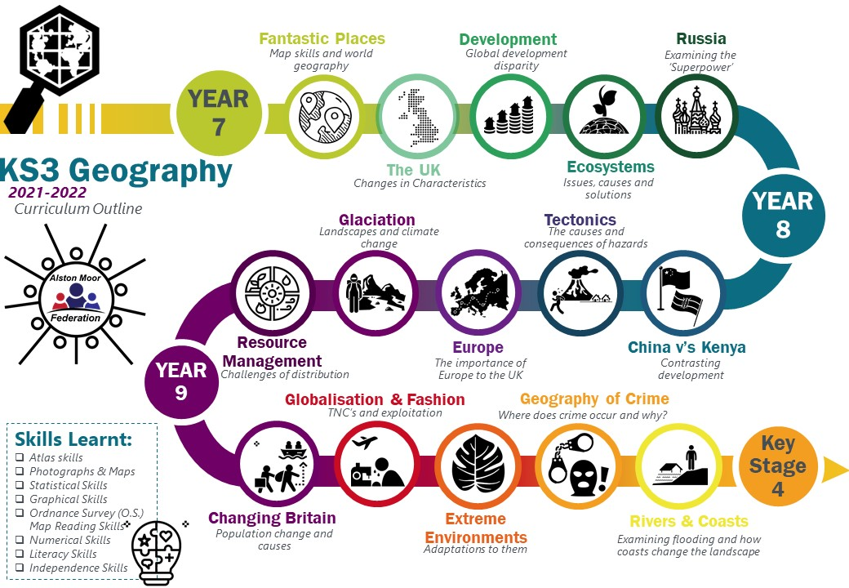
KS3 Design Technology

Mechanisms
- Problem solving skills
- Drawing skills
- Modelmaking skills
- Machinery skills
- Research skills
- Presentation Skills
- Reflective skills
- Independence Skills

6 r’s
Plastics

Production Methods
Textiles
Woods

Metals

Textiles

