Why is Performing Arts important?
The Performance Curriculum is designed to ignite our student’s creativity, passion and promote a lifelong love of the Arts.
Within Drama, Music and Dance students are given the opportunity to explore the world around them through the practical application of a wide range of styles, techniques and the study of practitioners. Students are encouraged to develop their group work skills as well as make independent decisions and communicate effectively. Throughout the Performance Curriculum the emphasis is on practical work and the development of performance skills and technique. Over time we aim to ensure students develop the following skills:
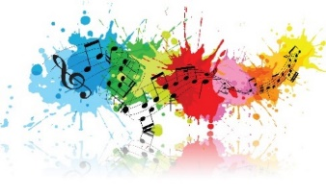
- Confidence & Communication - A command over their vocal and physical skills to allow them to approach a wide range of public speaking with confidence and communicate effectively.
- Concentration - Working on intricate projects over extended periods of time.
- Empathy and sensitivity - Understanding the viewpoints and emotions of a range of characters.
- Co-operation, collaboration and team-work skills - Getting the best out of each other when striving towards a common goal.
- Commitment and self-discipline - Encouraged and helped to excel when challenged, developing resilience and determination.
- Creativity and imagination - An understanding of the benefits of participation in the arts, performance and creativity.
- Evaluation and appreciation - An appreciation of the ways in which playwrights, choreographers and musicians create work and communicate their intentions to an audience and an ability to evaluate their own and others’ work.

What is the aim of the KS3 Performing Arts curriculum at SKS?
The Curriculum within all three areas of Performance at Key Stage Three is designed to increase confidence, communication, leadership and group work skills as well as building on technique and application through both key stages. The SKS Music Curriculum is about experiencing live and digital music through creativity and performance. Musicianship skills such as playing instruments, reading notation, analysing and listening to music are taught through practical projects. In Dance the curriculum is designed to promote students’ ability to feel comfortable with how their bodies move and aims to develop self-confidence and self-esteem. The key aims are to empower independent and creative learners who are able to appreciate dance as a form of expression and develop an understanding about what makes a good performance through the exploration of a range of styles, techniques and professional works. The Curriculum in Drama gives students a practical knowledge of how drama works as an art form and encourages them to recognise how drama is integral to cultures in different times and places. Key stage 3 develops the vital skills of independence, appreciation, concentration, cooperation, confidence, creativity, communication and critical thinking through the practical exploration of different genres, styles and performances.
How is the Performing Arts curriculum structured at SKS?
