Why is Performing Arts important?
The Performance Curriculum is designed to ignite our student’s creativity, passion and promote a lifelong love of the Arts.
Within Drama, Music and Dance students are given the opportunity to explore the world around them through the practical application of a wide range of styles, techniques and the study of practitioners. Students are encouraged to develop their group work skills as well as make independent decisions and communicate effectively. Throughout the Performance Curriculum the emphasis is on practical work and the development of performance skills and technique. Over time we aim to ensure students develop the following skills:
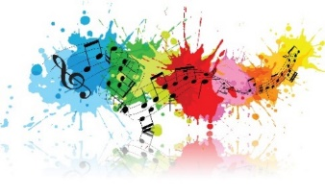
- Confidence & Communication - A command over their vocal and physical skills to allow them to approach a wide range of public speaking with confidence and communicate effectively.
- Concentration - Working on intricate projects over extended periods of time.
- Empathy and sensitivity - Understanding the viewpoints and emotions of a range of characters.
- Co-operation, collaboration and team-work skills - Getting the best out of each other when striving towards a common goal.
- Commitment and self-discipline - Encouraged and helped to excel when challenged, developing resilience and determination.
- Creativity and imagination - An understanding of the benefits of participation in the arts, performance and creativity.
- Evaluation and appreciation - An appreciation of the ways in which playwrights, choreographers and musicians create work and communicate their intentions to an audience and an ability to evaluate their own and others’ work.

What is the aim of the KS4 Performing Arts curriculum at SKS?
Students learn to express themselves in a safe environment. The main focus of teaching and learning is to encourage the free use of creativity and imagination, through exploration of story and character. Students will explore all performance subjects through looking at social themes and issues, key extracts from texts, different pieces of Music and dance and refining their skills and preparing them for the future. As their skills develop so too does their knowledge of the performing arts industry as we prepare students who are wanting to work in this field. Technical vocabulary is displayed throughout the faculty and used at all levels. Students are required to use very specific vocabulary at GCSE and BTEC level 2 so this is introduced early, explained and explored and linked to other words and areas of the curriculum. Knowledge organisers and glossaries are shared within student assessment booklets at KS3 and throughout GCSE and BTEC portfolios at KS4.
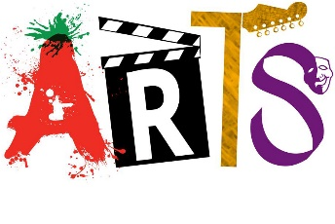
Students complete research components at KS4 into all areas of Performance and the industry so are encouraged to read and research as much as possible. It is a formal part of their assessment to present their findings work in a similar way to the creatives and teach others about a chosen area. Students are expected to view live theatre, listen to Music and experience live Dance as frequently as possible both to support their formal arts education but also as an on-going approach to raising cultural capital.
How is the Performing Arts curriculum structured at SKS?
