Why is Catering important?
Catering teaches students the important skills of cooking; imparting knowledge to the students so that they can lead successful independent lives when they are out of school. When dishes are prepared from scratch they can promote a healthy lifestyle as students learn where their food comes from, the benefits of the types of food used and how to maximise the value of nutrients. Students are exposed to a wider variety of food and dishes, and are more likely to eat the dishes they have made as they become curious to try new things.
Learning to cook from scratch also has the big advantage of being more economical and cheaper.

As well as this, studying food and hospitality can open the door to new careers for students; teaching them transferrable practical skills they need to pursue a career in these areas.

What is the aim of the KS3 Catering curriculum at SKS?

Studying Cooking and Nutrition at Samuel King’s School is about instilling a love of cooking as cooking is a great expression of creativity. Whilst doing this pupils acquire a strong understanding of nutrition. Learning how to cook is a life skill that enables our pupils to feed themselves and others a healthy and varied diet.
At Key Stage 3 pupils ​a develop basic understanding of nutrition and culinary skills which will lead them to develop confidence of cooking a range of dishes and make informed decisions about food.

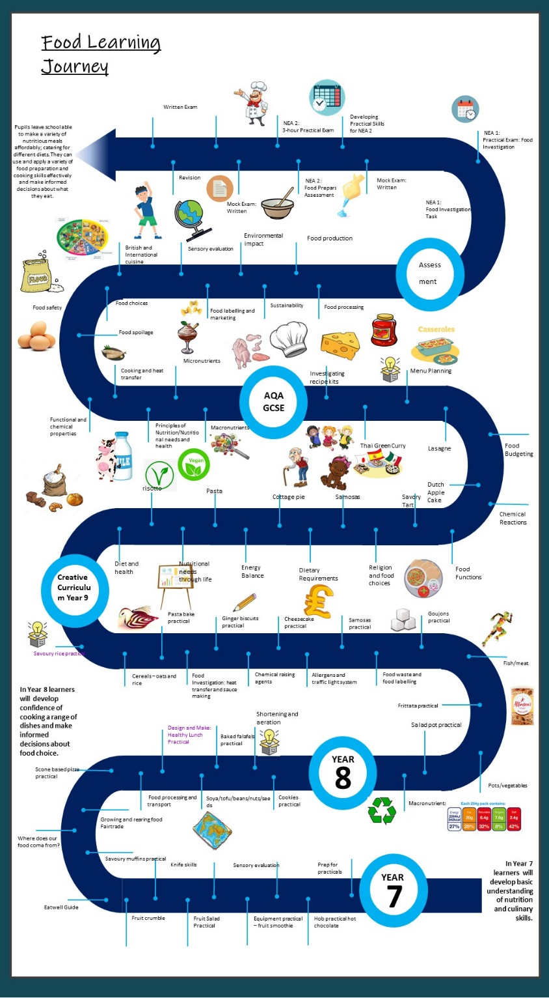
How is the Catering curriculum structured at SKS?

