Why is Food & Nutrition important?
Catering teaches students the important skills of cooking; imparting knowledge to the students so that they can lead successful independent lives when they are out of school. When dishes are prepared from scratch they can promote a healthy lifestyle as students learn where their food comes from, the benefits of the types of food used and how to maximise the value of nutrients. Students are exposed to a wider variety of food and dishes, and are more likely to eat the dishes they have made as they become curious to try new things.
Learning to cook from scratch also has the big advantage of being more economical and cheaper.

As well as this, studying the principles of food and hospitality can open the door to a variety of new careers for students; teaching them core practical skills they need to pursue a career in these areas.
What is the aim of the KS4 Food & Nutrition curriculum at SKS?

The five key GCSE strands are food, nutrition and health, food science, food safety, food choice and food provenance. Throughout their study of this subject, pupils will become competent in using a plethora of cooking techniques, using utensils and electrical equipment, applying heat in different ways, using sensory knowledge to decide how to season dishes and combine ingredients; adapting and using their own recipes. Studying food provenance, seasonality and characteristics of a broad range of ingredients.
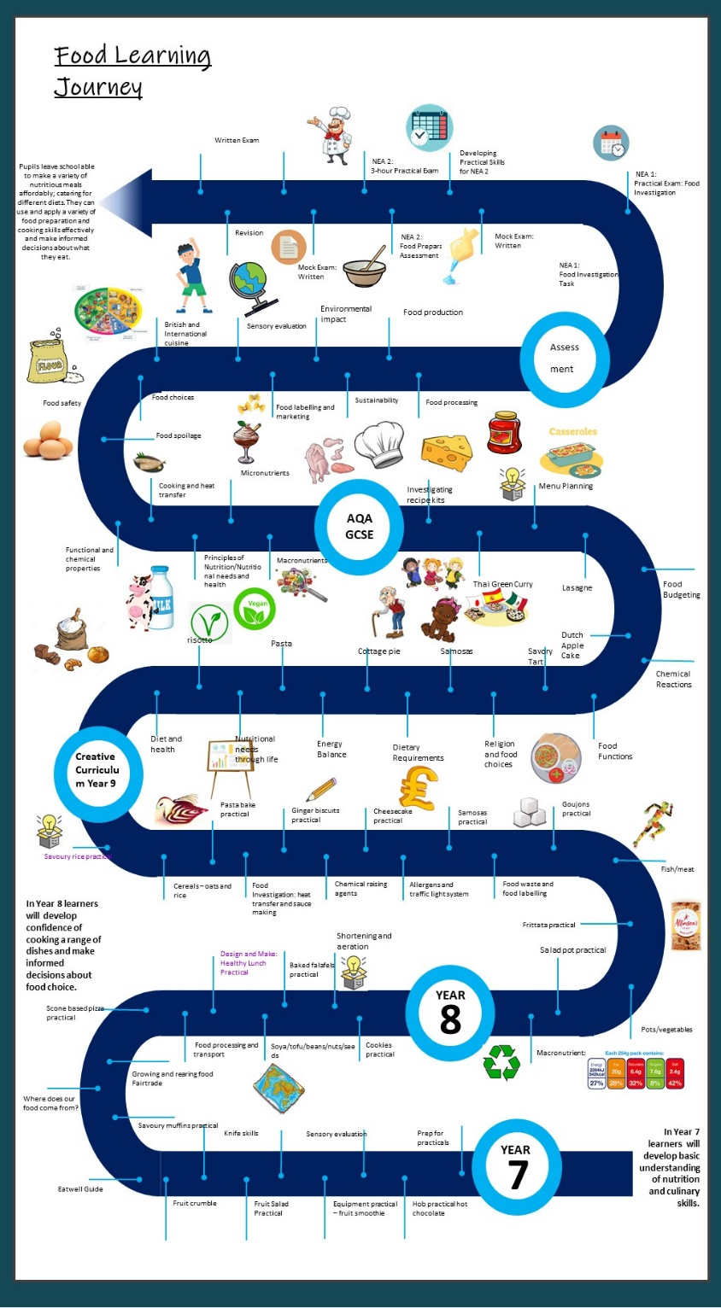
How is the Food & Nutrition curriculum structured at SKS?

