Why is English important?

English involves the study of the world around us and the ways in which this is experienced by a range of writers and thinkers in a variety of forms. The study of English allows pupils to express themselves academically and creatively for a range of forms and purposes, engage confidently in conversations whilst developing a love of literature.

What is the aim of the KS3 English curriculum at SKS?

At Samuel King’s we explore literature and language through reading, writing, and spoken language, covering 5 key strands across all years and both key stages. These are: poetry, a novel, Shakespeare, a non-fiction language unit and a spoken language unit. These common threads allow pupils to grow emotionally, intellectually and socially and acquire a strong command of spoken and written language as well as pursuing reading for enjoyment. Our curriculum is designed to be challenging and ambitious for all students, creating a culture of high expectations through exposure to the best that has been thought and written in the English language.

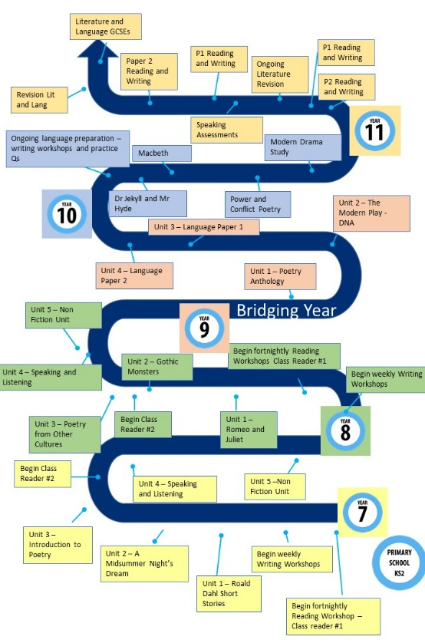
How is the English curriculum structured at SKS?

