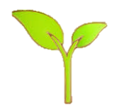

Flowering plants produce flowers to help them reproduce. They follow this life cycle:

Seed – Flowering plants begin life as seeds. They need soil, air and water to grow.

Seedling – When the plant first starts to grow, it is called a seedling.

Flowering – When the plant is fully grown, it will produce its own flowers. These flowers will eventually produce seeds. When the seed gets to the ground, the cycle starts again.

**Cross Fell Knowledge Organiser- Plants Year 1/2**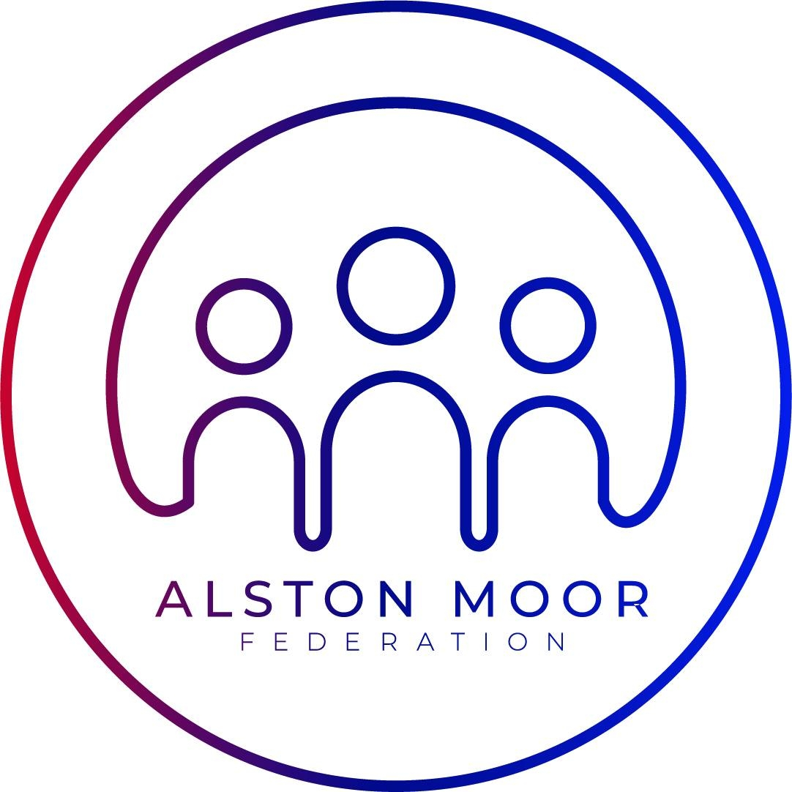

|  |  |  |  |  |  |  |  |
| --- | --- | --- | --- | --- | --- | --- | --- |
| **Overview** | |  | **Basic Structure of Plants** | | | | |
| **Previous knowledge- What should I already know?**  Plants can grow. The names of some common garden plants(e.g. poppy, rose) and the names of some common wild plants (e.g. daisy, dandelion, nettle). Deciduous trees lose their leaves in the autumn every year. Evergreen trees have green leaves all year round. The parts of a plant including petals, fruits, roots, bulbs, seeds, stem, trunks and branches.  -Plants are a large group of living things that use sunlight to make their own food.  -There are many, many different kinds of plants, including trees, vines and grasses.  -Plants have lots of different parts, for example stems, leaves and roots.  -Some trees lose their leaves in the winter (deciduous). Some keep their leaves through the year (evergreen).  -Some plants are ‘flowering plants’ – they grow flowers sometimes. | |  |  |  | -Plants are made up of many different parts.  -Roots – Roots absorb water and minerals from the ground. They also help the plant to stay standing in the ground.  -Stem – The stem supports the plant above the ground. It also helps to carry water and minerals from the roots to the leaves.  -Leaves – Leaves collect energy from the Sun and turn this into food for the plant (photosynthesis).  -Flowers and Fruits – Flowers and fruits help the plant to reproduce (to make more plants). |  | |
|  |
|  |  |  |
| **Types of Plants** | |  |
| **Trees**  Trees are tall, woody plants. They usually have a stem called a trunk.  -Some trees can live for hundreds or even thousands of years.  -Trees include birches, palms and pines. | **Moss**  Mosses are small, seedless plants that grow in moist places.  -Mosses grow together in large, thick mats.  -There are more than 10,000 different types of moss around the world. |  |  |  |  |
|  | | | | |
| **Flowering Plants** | | | | |
|  |  |  |  |  | |
|  |  |  |  |  | |
| **Bushes/Shrubs**  Bushes and shrubs are quite low plants that have lots of branches.  -Bushes do not normally grow as tall as trees.  -They include lavender, periwinkle and thyme. A shrubbery is a place with lots of shrubs. | **Vegetables**  -Vegetables normally come from a type of plant called a herbaceous plant. Vegetables can be eaten.  -Lettuce, spinach and broccoli are the leaves of plants. Asparagus is the stem of a plant. Some vegetables grow in the ground, e.g. carrots. |  |  |  |  | |
|  |  |  |  |  | |
|  |  | |
|  |  |  |  |  | |



What plants need to grow

**Key Vocabulary**

Root - The part of a plant that grows underground.

Flower – the part of a plant that is often brightly coloured and grows at the end

of the stem.

Stem – the thin, upright part of a plant on which the flowers and leaves grow.

Leaf/leaves – the part of a tree or plant that are flat, thin and usually green.

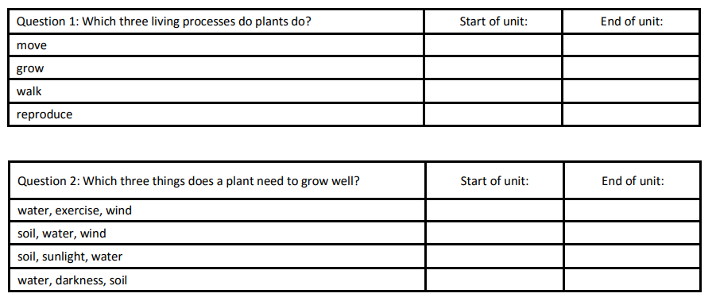

What I would like to know

Reflecting on my learning