Home school links
Useful websites-  https://www.bbc.co.uk/teach/school-radio/history-ks1-ks2-the-great-fire-of-london/z4bft39  https://www.bbc.co.uk/bitesize/topics/z7d7gwx/articles/zhgxcqt  https://www.london-fire.gov.uk/museum/learning-with-our-museum-curators/  https://www.childnet.com/resources/smartie-the-penguin/  https://whiterosemaths.com/1-minute-maths  https://www.oxfordowl.co.uk/for-home/find-a-book/library-page/ | Literacy- can you read 3 times per week with a grown up and ask them to write it in your reading diary. We will award stickers for you reading chart in school and you will get 1 dojo every time you read.    Can you write about someone who lived at the time of the great fire?  Don’t forget our must haves!  Capital letters, full stops, finger spaces, Fred talk and a lead in to your letters. |  |  |  | DT- Can you make a model Fire engine using junk modelling materials or construction materials.  You could design a new and improved fire engine if you prefer- we wonder what features you will include?  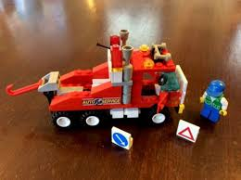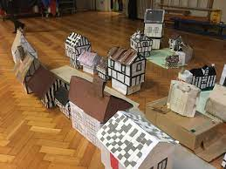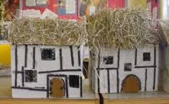  Or how about this…  Design and make your own Tudor house.
Science-  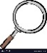  We are learning all about animals. Can you write about your pet or a pet you would like to have? What would it need to survive? How would it grow and change? What would it eat? Present you work however you choose. |  |  | Me and my Home- London’s burning.  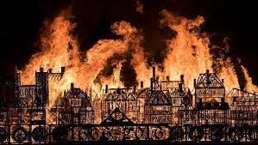  Cross Fell  Long term homework  Autumn Term 1 2024 | 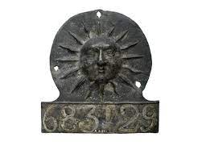  History-  Design your own fire mark as described by Elena in the London Fire Brigade information clip.  https://www.london-fire.gov.uk/museum/learning-with-our-museum-curators/
You choose!  Take your learning in your own direction.  Be as creative as you like and take your learning in a direction of your own choosing. |  | Art- Create or reproduce a picture showing a scene from London during the Great Fire. You could draw, paint, collage, use chalks or use a computer paint package to create your picture  . 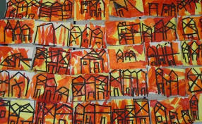 |  |  | 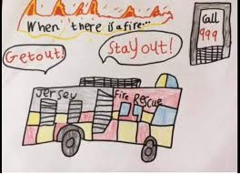  ICT- Use the internet to research then design a poster to promote Fire Safety.  What important rules do we need to remember? Remember our rules for staying safe online!
Please choose at least 2 of the activities from the table above and tick them off when you are done. Children may choose how to present their homework e.g. photos, writing, models etc, these are all in your child’s dojo portfolios.
Due in for a class presentation Wednesday 24th October when we will allow time for each child to come up and present their homework projects to their friends.
Useful websites-  https://www.bbc.co.uk/teach/school-radio/history-ks1-ks2-the-great-fire-of-london/z4bft39  https://www.bbc.co.uk/bitesize/topics/z7d7gwx/articles/zhgxcqt  https://www.london-fire.gov.uk/museum/learning-with-our-museum-curators/  https://www.childnet.com/resources/smartie-the-penguin/  https://whiterosemaths.com/1-minute-maths | Maths- We have been practising our numbers up to 50 for year 1 and to 100 for Year 2.  Ask an adult to challenge you by starting at any number and counting on. Can you go backwards too?  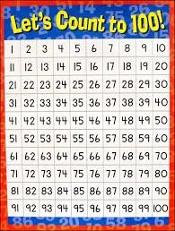 | DT - The Great Fire of London started in a bakery. With your grown bake some delicious bread or cakes. We would love to see what you baked so why not send us a picture on Class Dojo.  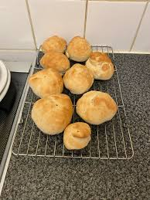
Literacy- Practise your handwriting remembering which letters should be taller or longer. You could use water and a paint brush, chalks, pens or pencils to write your letters.  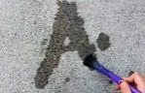  Keep working on learning to read and spell your tricky words. You can earn dojos for every improvement in your score | Me and my home- London’s burning  Cross Fell  Long term homework  Autumn Term 2- 2024 | History-  Pretend you are a news reporter in 1666. Write a newspaper report describing the event. Hint: What could you use to make your newspaper report look old?  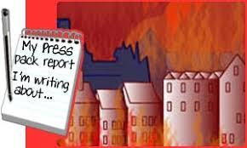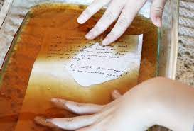
You choose!  Take your learning in your own direction. | Art and design- Draw a picture or make a model to show how you would have redesigned the city following the Great Fire show your creative flair when designing the new buildings. | ICT- Research ‘The Great Fire of London’ using the internet or books. Hand write or type up your findings in your own words. You may wish to add pictures downloaded from the internet.  Remember our rules for staying safe online. What would Smartie the penguin do?
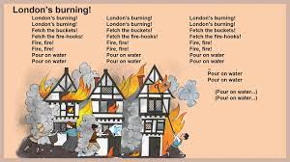
Music- In music we have been learning the song ‘London’s Burning’. Can you make up your own song about the Great Fire?’

Please choose at least 2 of the activities from the table above and tick them off when you are done. Children may choose how to present their homework e.g. photos, writing, models etc. Due in for a class presentation 18th December Please name all homework! Any photos can be emailed to either creed@alston.cumbria.sch.uk or bbrown@alston.cumbria.sch.uk

