## Numbots Parent/Carer Letter

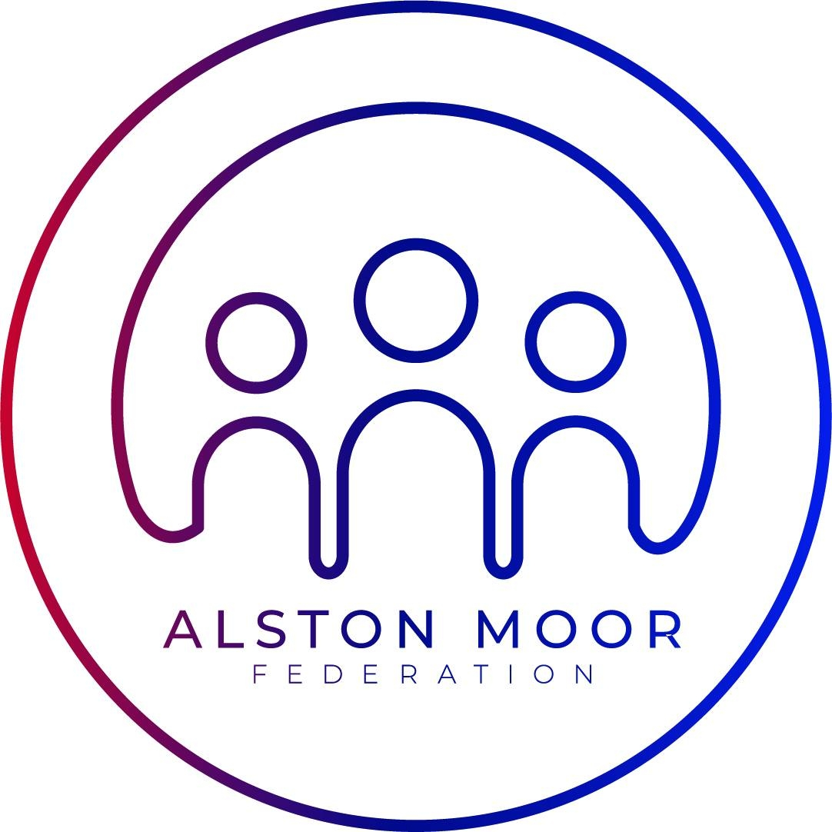

Dear Parent/Carer,

I’m delighted to inform you about an online learning platform called NumBots that we’re using to support your child’s understanding of number bonds and to help their addition and subtraction skills. These are the essential building blocks for higher-level maths concepts, so we are excited by the impact that NumBots will have on your child’s learning.

**Logging In**

The children have been shown how to log in and have brought home a username label containing their unique login details. NumBots can be played on a browser (play.numbots.com) or via the app which is free to download on Amazon, Android and Apple devices. They may need help entering the details, but once they’re in they will be able to play the game on their own.

Please ask one of the cross Fell team if you are struggling to login. Maths Circle (the creators of NumBots) cannot provide username and password information to parents, even during school holidays or out of hours.

**Important**: Please don’t allow siblings, friends or family to answer for them, as the programme progresses at the pace of each child. Do feel free to support your child if they’re stuck and give them encouragement to keep trying even if it takes a number of times to complete a level.

**Little and often**

In order to get the best out of NumBots, we recommend that children play regularly for short bursts at a time, aiming for 3 minutes, five times a week.

**Game Types**

1. *Story Mode* – the emphasis is on learning the ideas and concepts behind addition and subtraction so it features more diagrams, representations and question styles.
2. *Challenge Mode* – the emphasis is more on speed of recall of key facts, like number bonds to 10, doubling small numbers or adding & taking away in your head.

Please let your us know if you have any questions or comments.

Yours faithfully,

The Cross Fell Team