“The World at War: WWII Focus and Local Study”  Flinty Fell Spring Term 2025 |  | KEY AREAS OF LEARNING
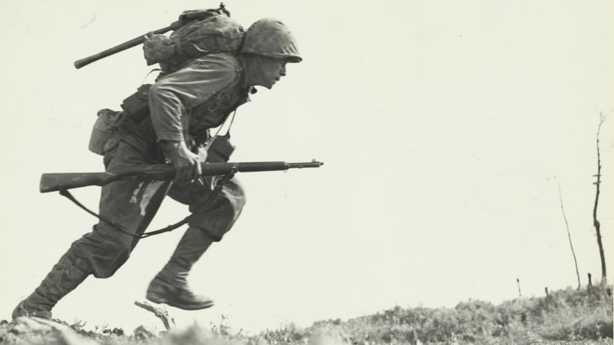  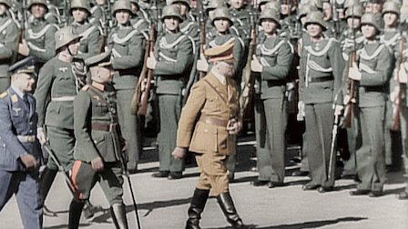  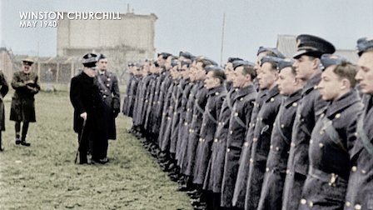  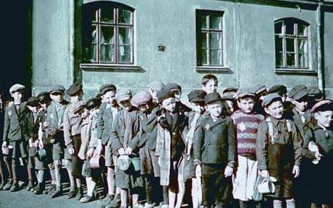  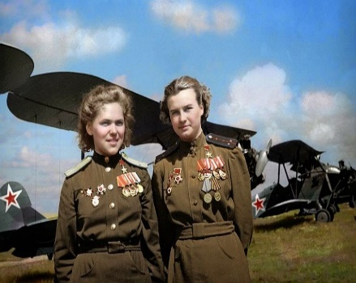  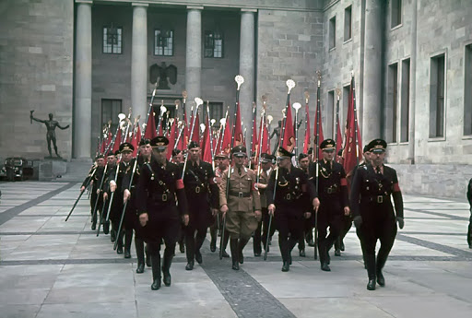 |  | To start the new year, we will study The Second World War. In Flinty Fell we will learn when and why World War II began, and find out about the key individuals and countries involved. In addition to this, we will discover all about evacuation; learn what it was like to live with food rationing and explore the contribution made by women to the war effort. Furthermore, we will learn important facts about the Holocaust and investigate events that were key turning points in the war, such as the Battle of Britain and the German invasion of Russia. Studying World War II will help children to develop their investigation and evaluation skills; learn to organise information chronologically and understand how past events have helped to shape the world we know today.  Assessment Statements  By the end of this half term, children will be able to:  • demonstrate a good understanding of a wide range of World War II events; • recall key dates and facts with ease; • evaluate and assess the reason, impact and significance of key wartime events; • explain the Holocaust in detail and make links and comparisons to issues today; •Develop a chronologically secure knowledge and understanding of world history, establishing clear narratives within and across the periods they study. •Understand methods of historical enquiry including how evidence is used to make historical claims. •Regularly address and sometimes devise historically valid questions about change, cause, similarity and difference and significance; •Know about the nature of ancient civilisations and characteristic features of past non-European societies. •Continue to develop a chronologically secure knowledge and understanding of British, local and world history, establishing clear narratives within and across the periods they study.  Across the wider curriculum we will develop our skills:  As WRITERS: We will secure our knowledge on different grammar terms and spelling rules by using a variety of activities to encourage children to apply these to their writing more fluently and regularly.  As MATHEMATICIANS: We will work hard on our Place Value, Addition and Subtraction, Multiplication and Division, and Fractions topics to extend and develop our knowledge on crucial number skills.  As GEOGRAPHERS: We will use appropriate geographical vocabulary to describe and explain how and why places are similar to and different from other places in the same country and elsewhere in the world. Additionally, we will recognise and explain patterns made by individual, physical and human features in the environment, along with justifying how these can cause changes in the differing surroundings. We will recognise how people can improve the environment or damage it, as well as analysing how decisions about places and environments affect the future quality of people’s lives.  As SCIENTISTS: we will use our Science topics as a great way to find out about the world around us. Our topic in Science this term is Electricity. We will be encouraged to raise questions, plan and set up fair tests, take accurate measurements, look out for any patterns and record their data in the best way such as tables, scatter graphs or bar graphs. We will then use these results to make predictions leading to further tests and finally, reaching conclusions about their original question whilst understanding the level of reliability of their results. We are very much looking forward to our Science topic of Light!  As ARTISTS and DESIGNERS: We will learn how to produce detailed sketches and drawings. Children will be introduced to the concept of perspective, working on different scales. We will also have the opportunity to work on a variety of textured surfaces and investigate the direction of light shining on an object. WWII inspired artwork will provide the inspiration for our creations this term.
Outdoor Learning | Communication and Collaboration |  | Around the World News | Sustaining our Environment
This term, we have P.E and Performing Arts sessions during the week, that will help extend our learning outside of the classroom, as well as keeping us fit and active. | We live in an ever-changing world that can throw a number of different challenges our way. Therefore, in Flinty Fell our pastoral sessions will continue to have high importance in our daily routines, to make sure we establish a safe and nurturing atmosphere for the children to express themselves and produce a consistent learning environment. |  | We will continue to develop our awareness and understanding of current events affecting our world through discussions in our PHSE sessions, as well as discussing important current events during our morning bulletin sessions. Additionally, we will debate the key issues we read in articles found on reputable organisations such as the BBC (Newsround). | We will consider and explore all the different ways our planet is affected by human behaviour, as well as considering the types of strategies and changes we can make to help our world become of safer place for all living things.

