Class 4 Spelling Tests
Given: 1.12.23
Test: 8.12.23
Spelling Tests: Group A
Spellings
chef
machine
parachute
crochet
chute
brochure

Spelling test: Year 5
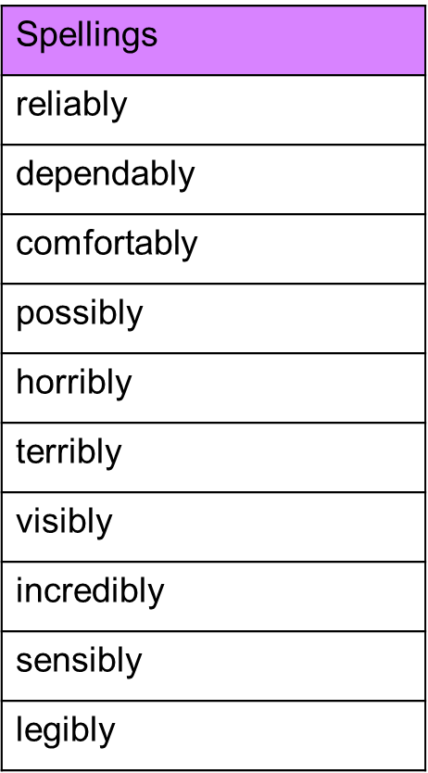

Spelling Tests: Group B
Spellings
forgetting
forgotten
beginning
preferred
committed
equipped

Spelling test: Year 6

