Class 4 Spelling Tests
Given: 10.11.23
Test: 17.11.23
Spelling Tests: Group A
Spellings
admiration
observation
location
generation
combination
exploration

Spelling test: Year 5
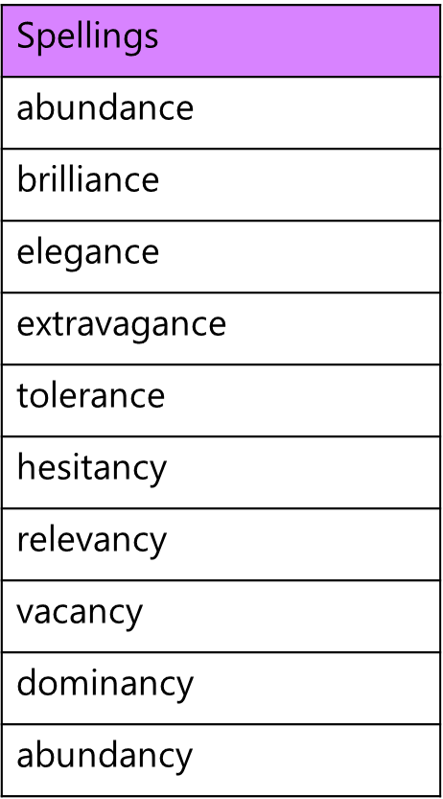

Spelling Tests: Group B
Spellings
disappoint
disappear
disable
dislike
disadvantage
disagree

Spelling test: Year 6
