Class 4 Spellings
Given: 10.5.24
Test: 17.5.24

Spelling test: Group A
Spellings
supermarket
superhero
superstar
antisocial
autograph
automatic

Spelling test: Year 5
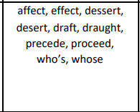

Spelling test: Group B
Spellings
berry
break
brake
male
mail
bury

Spelling test: Year 6
No Spelling test for Sats week

