Class 4 Spellings
Given: 12.1.24
Test: 19.1.24
Spelling Test: Group A
Spellings
courageous
nervous
famous
adventurous
ridiculous
carnivorous

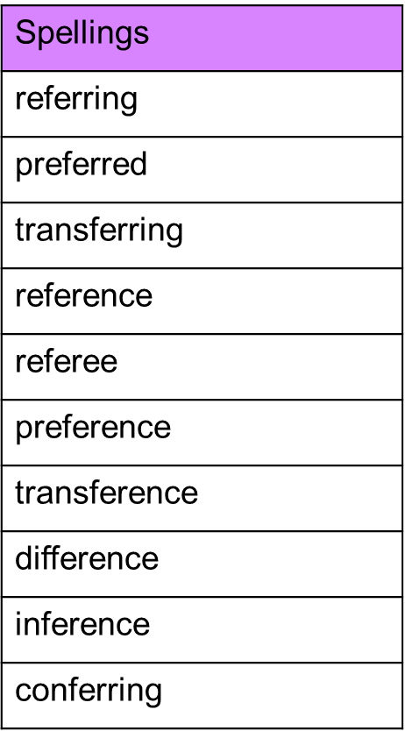
Spelling test: Year 5

Spelling Test: Group B
Spellings
obey
prey
they
grey
survey
disobey

Spelling test: Year 6
Spellings
produce
impact
transport
silence
permit
object
contest
subject
increase
freeze

