Class 4 Spellings
Given: 12.7.24
Test: 19.7.24

Spelling test: Group A
Spellings
gently
potatoes
circus
microphone
separate
affect

Spelling test: Year 5
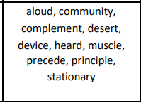

Spelling test: Group B
Spellings
disappear
reaction
committed
forbidden
neighbour
personal

Spelling test: Year 6
