Class 4 Spelling Tests
Given: 13.10.23
Test: 20.10.23
Spelling Test: Group A
Spellings
interact
intercept
intercom
interface
internet
interview

Spelling test: Year 5
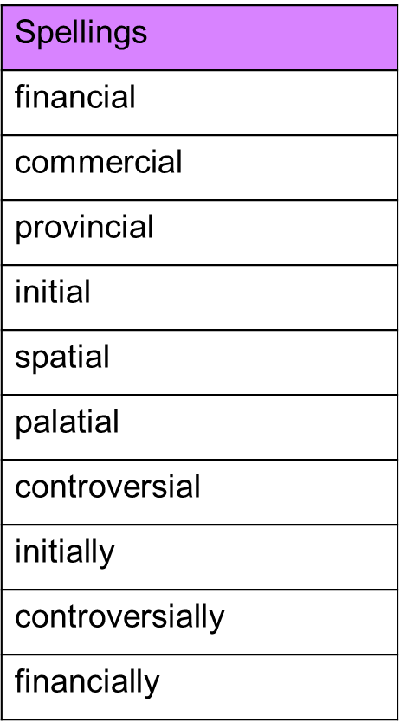

Spelling Test: Group B
Spellings
adventure
future
picture
nature
creature
mixture

Spelling Test: Year 6
