Class 4 Spellings
Given: 14.6.24
Test: 21.6.24

Spelling test: Group A
Spellings
Girls’
Boys’
Babies’
Children’s
Geese’s
Ladies’

Spelling test: Year 5
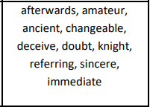

Spelling test: Group B
Spellings
special
strange
difficult
important
length
position

Spelling test: Year 6
