Class 4 Spelling Tests
Given: 15.12.23
Test: 22.12.23
Spelling Test: Group A
Spellings
expansion
extension
tension
provision
explosion
invasion

Spelling test: Year 5
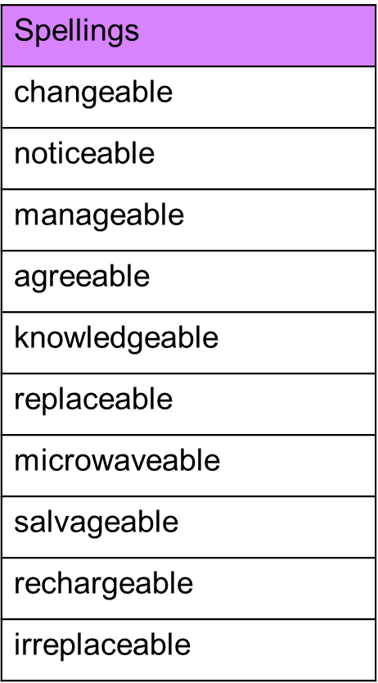

Spelling Test: Group B
Spellings
straight
fainted
claimed
waist
snail
painter

Spelling test: Year 6
