Class 4 Spelling Tests
Given:15.9.23
Test: 22.9.23
Spelling test: Group A
Spellings
Accept
Except
Plain
Plane
Weather
Whether

Spelling test: Year 5
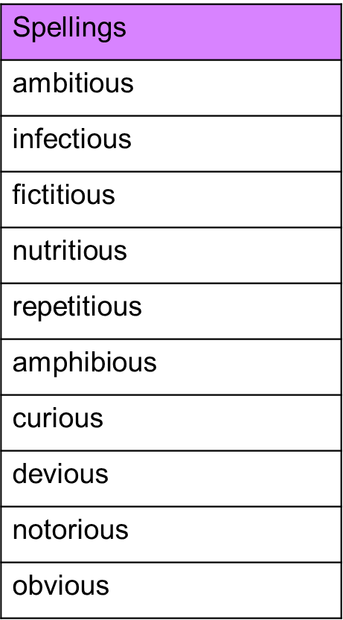

Spelling test: Group B

Spellings
around
sound
proud
found
ouch
mouth

Spelling test: Year 6
