Class 4 Spellings
Given: 19.1.24
Test: 26.1.24
Spelling test: Group A
Spellings
happiness
plentiful
happily
prettiest
beautiful
silliness

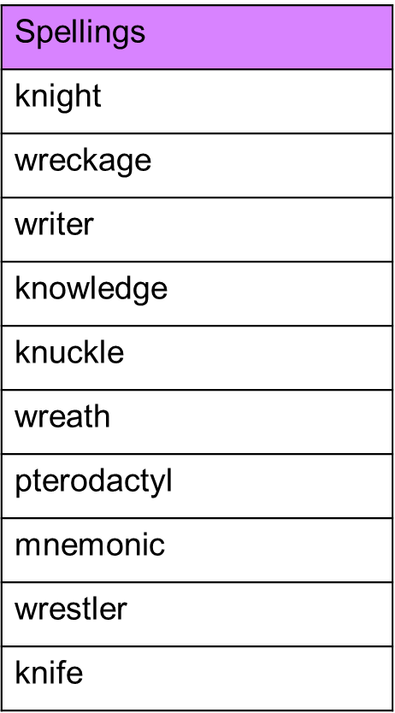
Spelling test: Year 5

Spelling test: Group B
Spellings
calmly
exactly
bravely
gladly
deeply
clearly

Spelling test: Year 6
