Class 4 Spellings
Given: 2.2.24
Test: 9.2.24
Spelling Test: Group A
Spellings
although
breath
caught
different
thought
business

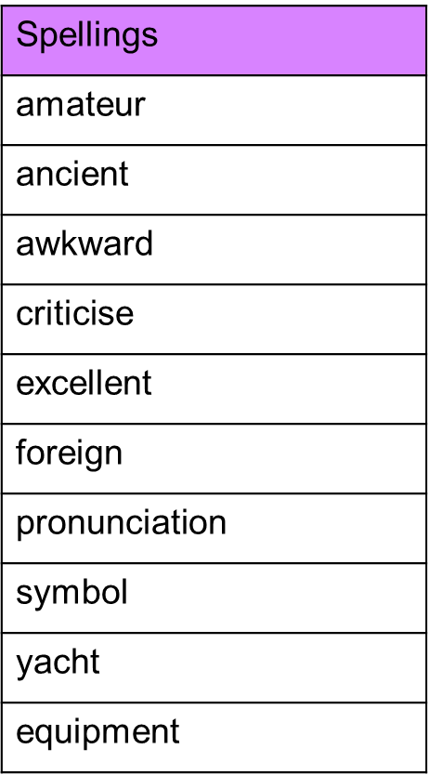
Spelling test: Year 5

Spelling Test: Group B
Spellings
build
describe
weight
natural
promise
recent

Spelling test: Year 6
