Class 4 Spelling Tests
Given: 20.10.23
Test: 27.10.23
Spelling Test: Group A
Spellings
strength
calendar
women
appear
straight
believe

Spelling test: Year 5
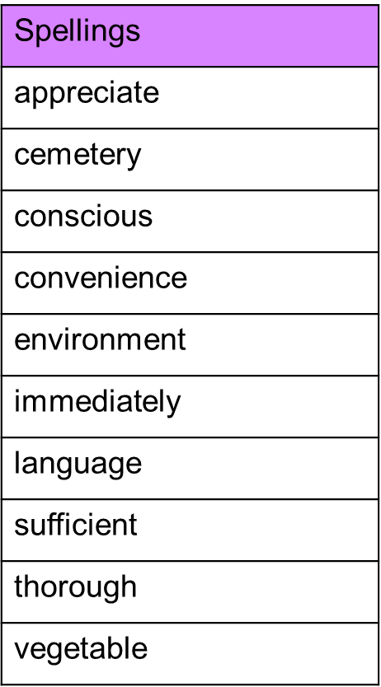

Spelling Test: Group B
Spellings
actual
bicycle
answer
circle
earth
enough

Spelling Test: Year 6
