**ANSON CE PRIMARY SCHOOL**

**Main Road**

**Great Haywood**

**Stafford**

**ST18 0SU Tel no: 01889 881200**

**email** [**office@anson.staffs.sch.uk**](mailto:office@anson.staffs.sch.uk)

**Headteacher: Miss Jarrett**

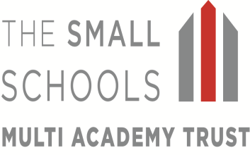

Dear Parents/Carers,

Welcome to a brand new school term! We hope you all had a fantastic Easter break! Class Four will begin the term with a new topic about the Aztecs. We will discover where and when the Aztecs lived, how they lived their lives and how the Aztec empire was defeated in the 16th century. You can see more details of this in the curriculum web on the following page.

**How can I help my child?**

If you would like to support your child’s learning in class you can help them in the following ways:

* Ensure your child knows their times tables, up to 12x12. (It is an expectation that all children in year 5 and 6 already know all their times tables and should be able to recall them quickly)
* Allow your child to access Education City or Bug Club at home if possible. These educational programs allow your children to access games related to Literacy and Numeracy and are all related to the curriculum. (Please feel free to encourage them to access these sites at anytime, not just when set for homework).
* Please continue to listen to your child read every day for a **minimum of 10 minutes**. This reading should be recorded in their homework diaries.
* Please sign the homework diaries **weekly**. These will be checked and signed by the class teacher on Fridays. If messages from home are written throughout the week, please encourage your child to share their homework diary with the class teacher.

**Reminders**

**Spellings:** Class 4’s spellings are given out on a Tuesday and are tested on the following Tuesday. Your child can play set games on Spelling Shed to help them learn them. If you would like to support your child further, you will find a list of words that the children are expected to know by the end of Year 6 on page 100 in the children’s homework diaries.

**Homework:** Homework will be sent out on a **Friday** and must be returned by the following **Friday** in the given homework folder. Please encourage your child to take care with their homework, using neat handwriting in either a pencil or a pen. Homework is intended to be a consolidation of our class work and should therefore not be too challenging for your child to complete, although any help received from an adult will support their learning and improve confidence. If your child has any difficulties with their homework, please put a note in their diary.

**Water bottles:** Each child should have a water bottle in school that is clearly named. The children can have a drink from these at convenient times throughout the school day and they are sent outside at breaks and lunches.

**Uniform:** Please ensure that all uniform, especially jumpers and cardigans are clearly labelled with your child’s name inside. Ties are expected to be worn with shirts or alternatively your child can wear a polo shirt. Where possible, please ensure clothing has the Anson logo.

**PE:** Please ensure that your child has an Anson PE top in their house colour and PE shorts as well as appropriate footwear. This year, PE will be on a **Monday and Friday** so please make sure that your child brings in their kit at the beginning of the week.

**Open Door Policy:** Please do not hesitate to contact me at school if you have any concerns; the open door policy at Anson means I am available for 15 minutes before or after school to talk through any problems. If you need longer, we can arrange a mutually agreeable time. Please ask at reception if you wish to speak to me before school.

Kind Regards

**Miss Spennewyn , Mrs Castell & Mrs Chell**Class 4’s Teacher and Teaching Assistants

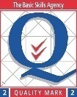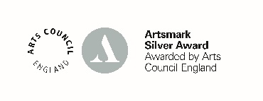

Numeracy:

In Numeracy, we will be focusing on a variety of topics such as Decimals, Shape and Statistics. Year 6’s will also be recapping and revising topics previously covered earlier in the year.

History:

In History, we will be finding out about the Aztecs! The Aztecs is a fascinating topic to study, full of exciting stories, amazing innovations and one or two more gory elements!

We will discover where and when the Aztecs lived, how they lived their lives and how the Aztec empire was defeated in the 16th century.

**Aztecs!**

RE:

In RE lessons, we will be learning all about the Islamic faith, answering the question “What does it mean to be a Muslim today?”

Computing:

This term we will be learning all about the creation of the world wide web as well as our school network. We will also be using a variety of softwares on Purple Mash to play and create our own quizzes.

Art:

In our Art lessons we will be studying how the Aztecs used and made mosaics and will be doing some Aztec cooking!

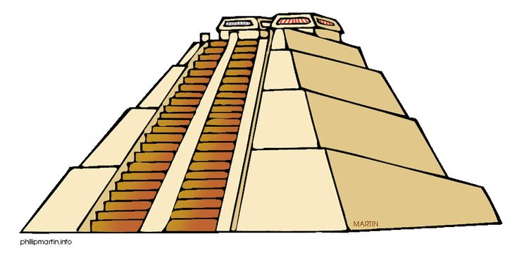

Science:

We will be carrying out a unit of work on evolution and inheritance. We will be thinking about characteristics passed from one generation to the next and how species have adapted to suit their environments. We will also be learning about animals including humans including how our bodies change and develop.

Literacy:

In literacy we will be writing a narrative folktale based on the book The Chocolate Tree: A Mayan Folktale. When we return from our residential, we will be writing a recount of the events, and we will also be writing a variety of other pieces such as a letter of complaint focusing on levels of formality!

Music:

Miss Lambert will be delivering high quality and exciting Music lessons!

PE:

Athletics and Cricket

French:

Madame Eliot will continue to deliver exciting and engaging French lessons!