Class 4 Spellings
Given: 21.6.24
Test: 28.6.24

Spelling test: Group A
Spellings
expression
musician
group
scene
circle
solve

Spelling test: Year 5
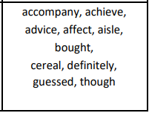

Spelling test: Group B
Spellings
exactly
bravely
island
decide
survey
promise

Spelling test: Year 6
