Class 4 Spelling Tests
Given: 22.9.23
Test: 29.10.23
Spelling Test: Group A
Spellings
inability
inactive
incorrect
indefinite
insecure
invisible

Spelling test: Year 5
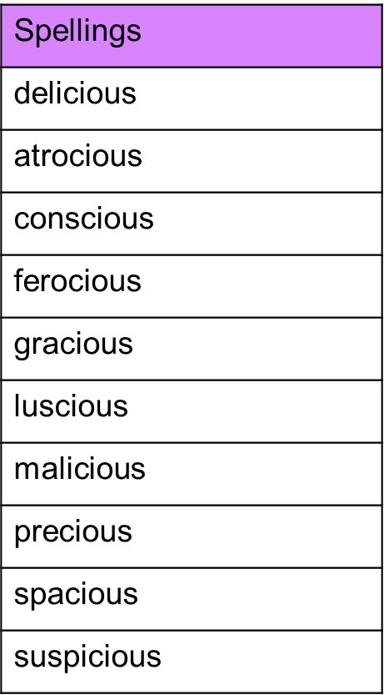

Spelling Test: Group B
Spellings
touch
double
country
enough
young
trouble

Spelling test: Year 6
