Class 4 Spellings
Given: 26.1.24
Test: 2.2.24
Spelling Test: Group A
Spellings
serious
obvious
curious
furious
various
victorious

Spelling test: Year 5
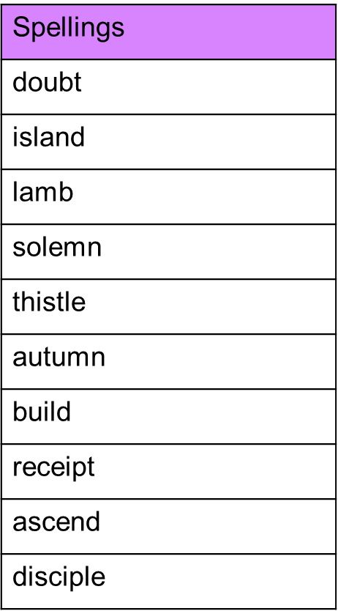

Spelling Test: Group B
Spellings
great
main
grown
meet
mist
meat

Spelling test: Year 6
