Class 4 Spellings
Given: 28.6.24
Test: 5.7.24

Spelling test: Group A
Spellings
incorrect
subject
believe
wildly
bravely
thoughtfully

Spelling test: Year 5
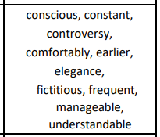

Spelling test: Group B
Spellings
hourly
missed
suppose
daily
descend
automatically

Spelling test: Year 6
