Class 4 Spelling Tests
Given: 29.9.23
Test: 6.10.23
Spelling Test: Group A
Spellings
illegal
immature
impossible
impatient
irregular
irresponsible

Spelling test: Year 5
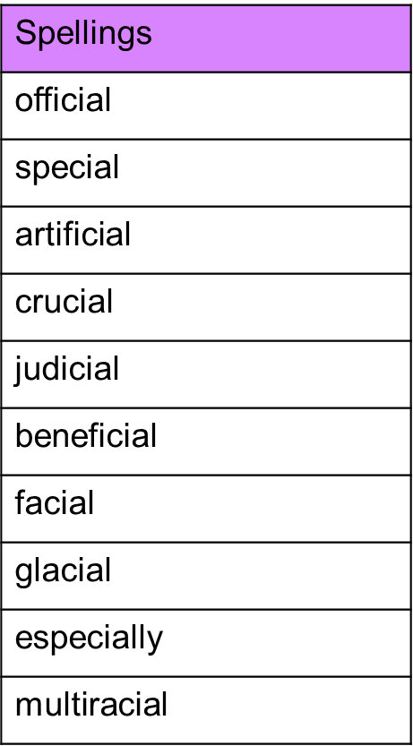

Spelling Test: Group B
Spellings
symbol
gym
lyrics
system
myth
mystery

Spelling test: Year 6
