Class 4 Spellings
Given: 3.5.24
Test: 10.5.24

Spelling test: Group A
Spellings
signal
telephone
assign
microphone
sign
design

Spelling test: Year 5
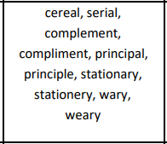

Spelling test: Group B
Spellings
science
scene
scissors
scented
scenery
descend

Spelling test: Year 6
