Class 4 Spellings
Given: 3.6.24
Test: 7.6.24

Spelling test: Group A
Spellings
bicycle
biplane
biannual
biscuit
biceps
binoculars

Spelling test: Year 5
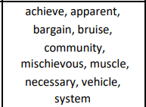

Spelling test: Group B
Spellings
breathe
century
eight
consider
guard
heard

Spelling test: Year 6
