Class 4 Spellings
Given: 5.7.24
Test: 12.7.24

Spelling test: Group A
Spellings
famous
tension
different
astronaut
admission
mathematician

Spelling test: Year 5
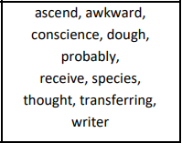

Spelling test: Group B
Spellings
teacher
history
mention
regular
disable
eighteen

Spelling test: Year 6
