Class 4 Spelling Tests
Given: 6.11.23
Test: 10.11.23
Spelling Test: Group A
Spellings
information
preparation
decoration
donation
population
determination

Spelling test: Year 5
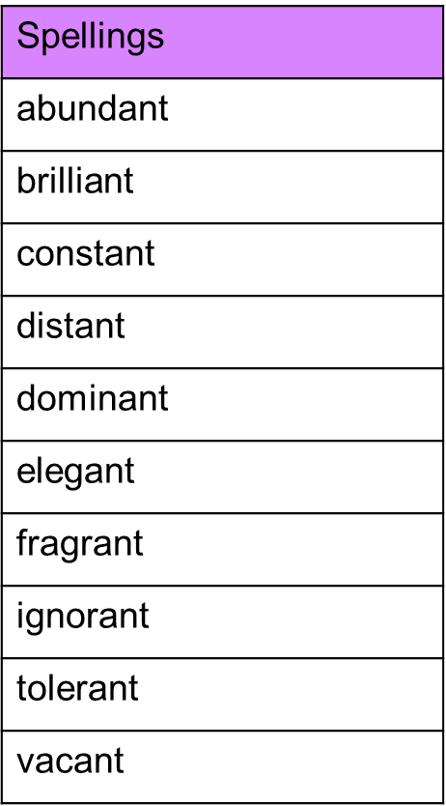

Spelling Test: Group B
Spellings
return
refresh
reappear
review
replay
revenge

Spelling Test: Year 6
