Class 4 Spellings
Given: 7.6.24
Test: 14.6.24

Spelling test: Group A
Spellings
guide
possess
forwards
accident
eighth
Wednesday

Spelling test: Year 5
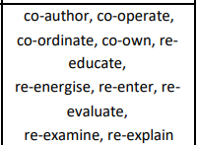

Spelling test: Group B
Spellings
vision
division
television
invasion
decision
revision

Spelling test: Year 6
