Class 4 Spelling Tests
Given: 8.12.23
Test: 15.12.23
Spelling Tests: Group A
Spellings
favourite
complete
continue
February
material
remember

Spelling test: Year 5
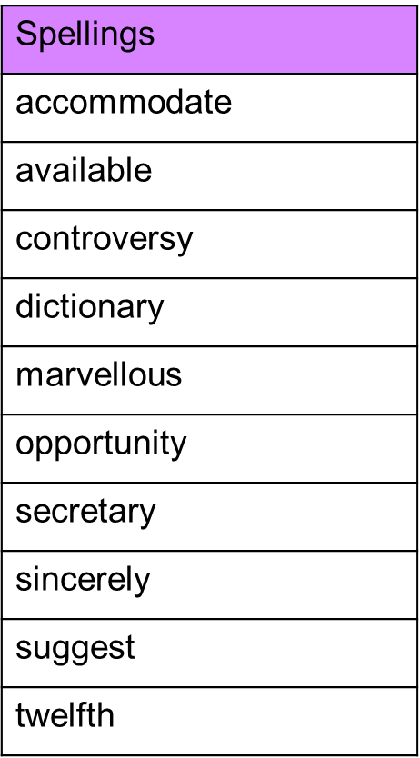

Spelling Tests: Group B
Spellings
centre
disappear
heart
minute
early
learn

Spelling test: Year 6
