ANSON CE PRIMARY SCHOOL

Main Road
Great Haywood
Stafford
ST18 0SU Tel no: 01889 881200
Email: office@anson.staffs.sch.uk"
Headteacher: Miss N. Jarrett

Dear Parents/Carers,

Welcome to Anson Primary School! We hope you have had a lovely summer and are looking forward to your child starting their learning journey at Anson. The Early Years team is made up of Mrs Heath, Mrs Rock, Mrs Broome and Mrs Bater.

We spend much of our first term getting to know your child and our first two topics are ‘All about me’ and ‘People who help us’. You can find details of our intended learning over the page. The children will be working towards individual targets and reaching their Early Learning Goals throughout the year. A baseline assessment will be done in the first few weeks of the term, it is nothing to worry about it just helps us to see where your child is currently at and where they are in their learning.
Class Information:

Before and After school routines: The school gates are open from 8.30am, Class 1 children should line up and enter at the blue Early Years gate in the playground. They will be greeted by a member of the early years team and led into the classroom. At the end of the day please collect your child from this same gate, where children will be dismissed one at a time to their collecting grown up.

Uniform: Please ensure that ALL uniform including PE kits are clearly labelled with your child’s name. Your child will also need to have a bag with a spare change of clothes that can stay in school - just in case!

PE: Class 1 has P.E every Wednesday, please ensure your child brings their labelled PE kit to school in their PE bag.

Snack & Milk: All children are provided with fruit and milk every day at snack time free of charge.

Water bottles: Each child should bring a water bottle into school that is clearly named, bottles will be returned home at the end of each day for washing and refilling. Children can have a drink from these at any time throughout the school day and are also sent outside at breaks and lunches.

Wellies: Please ensure that your child brings in a pair of wellies with them on their first day, which are clearly labelled. These will be kept in school throughout the year, we try to go outside in all weathers in our rain suits!

Readers: After the first few weeks of this term your child will begin to bring home a reading book. Initially these will be books with just pictures, this is a lovely way to begin sharing story time with your child and begin their excitement for reading. Following assessments and where we are at in our phonics scheme your child will bring home reading books at their stage of reading. Reading books should be read each night, please help your child to read and enjoy their book and write a comment in their diary to show us that your child has read or any comments you would like to pass on. Reading books will be changed on a Monday if they are bought in with the diary signed. Your child also has a login to 'Bug Club' where they have a variety of reading books set for them that they can access at home. Lots of children enjoy reading through Bug Club and this could be used if your child has finished their book

Diaries: Diaries will be checked every day for messages. They form an important line of communication between home and school, so please let us know any information on the right hand side of the page. It is helpful to write in the diary who will be picking your child up that day so we know who to look for and if it is someone new we can ask for your child’s password.

Open Door Policy: Please do not hesitate to contact me at school if you have any questions or concerns, the open door policy at Anson means I am available for 15 minutes before or after school to talk through any problems. If you need longer, we can arrange a mutually agreeable time.

We look forward to an exciting half term.

Kind regards,

Mrs Heath, Mrs Rock, Mrs Broome and Mrs Bater
Class 1s Teacher and Teaching Assistants
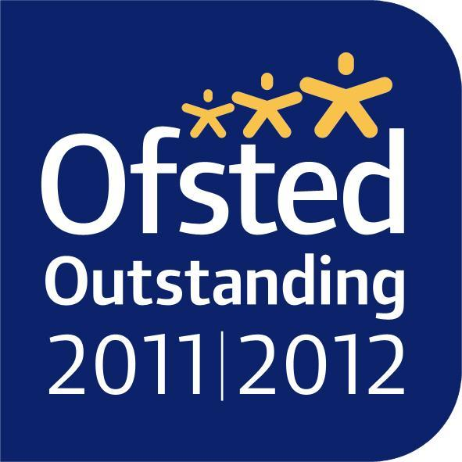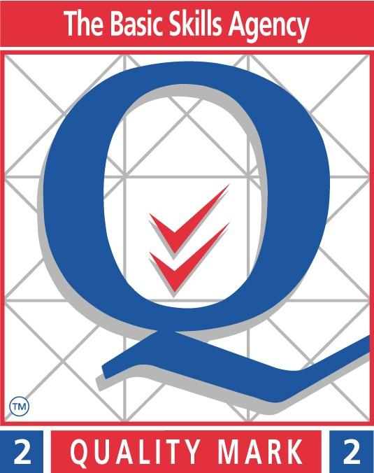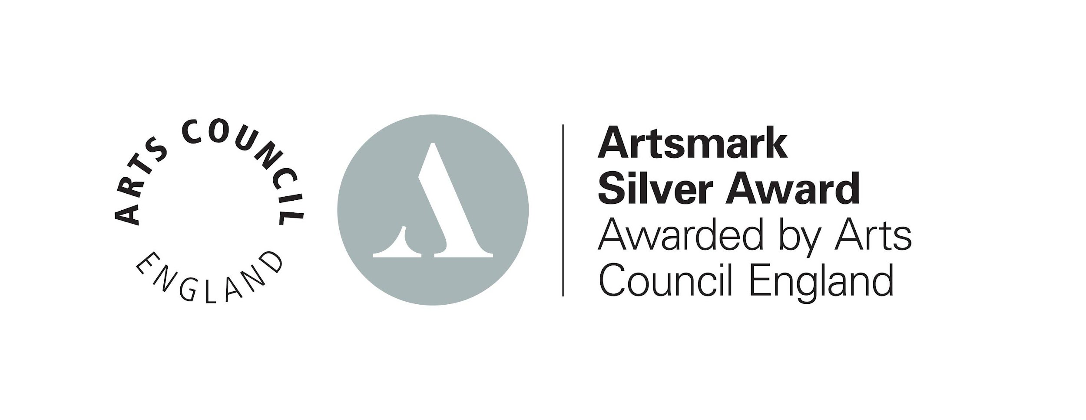
Topic Web Autumn Term
Phonics
Consolidating Phase 1 Phonics
Phase 2 Monster Phonics
Beginning to blend and segment simple words
Phase 2 tricky words

Reading
Discussing pictures telling a story
Emotions

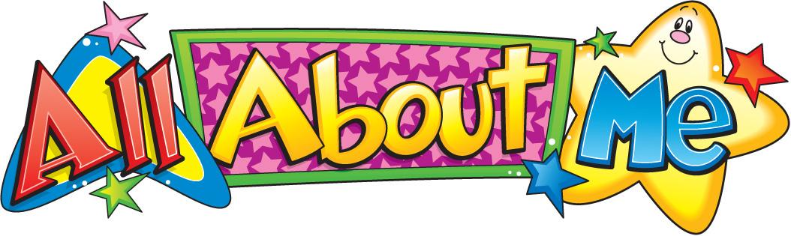

Literacy
Mark making
Letter formation
Listening to and discussing key elements of stories
Name writing
Writing initial sounds and simple words using phase 2 sounds

Numeracy
Recognising and understanding numbers
Subitising and unitising
Active Maths
Maths songs and rhymes
Pictograms

PE
Gross and fine motor skills
Spatial awareness
Using our bodies to create different movements

RE
Creation
I am special
Looking at ourselves, our families
School values
Expressive arts & design
Using media and materials to create pictures
Rhythm using percussion
Music to accompany stories
Role play
5 a day

Understanding of the world
All about me – My Family, Likes & Dislikes, My School & Local area
Diwali, Bonfire Night, Autumn, Hibernation
How people help us and the jobs they do

