ANSON CE PRIMARY SCHOOL

Main Road
Great Haywood
Stafford
ST18 0SU Tel no: 01889 881200
email office@anson.staffs.sch.uk

Headteacher: Miss N. Jarrett



Dear Parents/Carers,
Welcome to Anson Primary School! We hope you have had a lovely summer and are looking forward to your child starting their learning journey at Anson. My name is Miss Heath and I will be your child’s teacher this year, working alongside teaching assistants Mrs Grant and Mrs Broome.
Our first two topics are ‘All about me’ and ‘People who help us’. You can find details of our intended learning over the page. The children will be working towards individual targets and reaching their Early Learning Goals throughout the year. A baseline assessment will be done in the first few weeks of the term, it is nothing to worry about it just helps us to see where your child is currently at and where they are in their learning.
Class Information:

Uniform: Now your child has their new school uniform, please ensure that ALL uniform including PE kits are clearly labelled with your child’s name. This helps to ensure if at any time anything does get lost it can easily be returned to you.
Please also have a spare change of clothes for your child that can stay in school, just for those messy moments!

Aprons: Due to the current situation and the children not being able to share our class aprons we have asked for you to kindly provide a painting apron or an old shirt that your child can use during messy play or creative activities. We will send these home every Friday to be washed.

PE: Class 1 will have P.E every Tuesday morning, so it is important that they bring their labelled P.E kit in as soon as possible, due to current circumstances P.E kits will be sent home for washing every Friday and must be returned on the following Monday.

Snacks: Children in class 1 will be provided with fruit each day which we all eat together at snack time.

Milk: Children who have not yet reached their 5th birthday will receive free milk daily. Once your child reaches 5, to continue receiving milk you will need to fill in a form at the office and pay using parent pay.

Water bottles: Each child should bring a water bottle into school that is clearly named, the children can have a drink from these at any time throughout the school day and are also sent outside at breaks and lunches. Bottles will be returned home at the end of each day for washing and refilling.

Wellies: Please ensure that your child brings in a pair of wellies to be kept at school, which are clearly labelled with your child’s name. As we try to go outside in all weathers in our rain suits!

Readers: After the first few weeks of this term your child will begin to bring home a reading book. Initially these will be books with just pictures, this is a lovely way to begin sharing story time with your child and begin their excitement for reading. Following assessments and where we are at in our phonics scheme your child will bring home reading books at their stage of reading. Reading books should be read each night, please help your child to read and enjoy their book and write a comment in their diary to show us that your child has read or any comments you would like to pass on. Reading books will be changed on a Monday, Wednesday and Friday if they are bought in with the diary signed. Lots of children enjoy reading through Bug Club and this could be used if your child has finished their book on a Tuesday or Thursday.

Logins: Inside the front cover of your child’s school diary you will find your child’s logins for a variety of apps and websites that your child can use at home. We will use these in the classroom throughout this term to familiarise your child with how to use these.

Diaries: Diaries will be checked every day for messages and they form an important communication between home and school, so please let us know of any information on the right hand page of the diary. It is helpful to write in their diary who will be picking your child up that day so we know who to look for and if it is someone new we can ask for your child’s password.

Open Door Policy: Due to current circumstances, if you have any issues, please contact the school office so we can arrange a mutually convenient telephone appointment to discuss any problems.
We look forward to an exciting half term.
Miss Heath Mrs Grant & Mrs Broome
Class 1 Teacher Class 1 Teaching Assistants
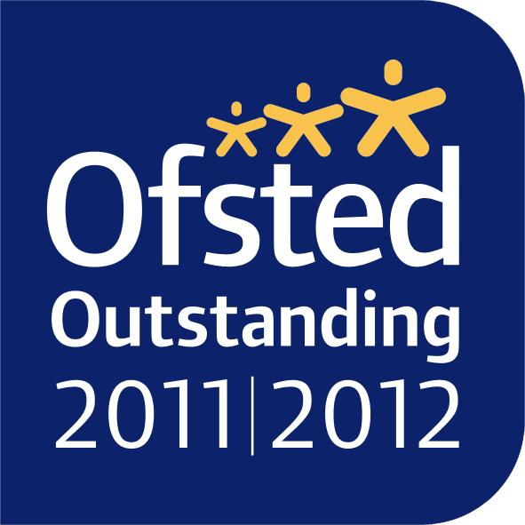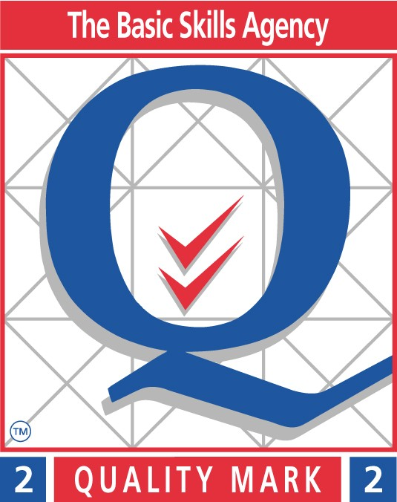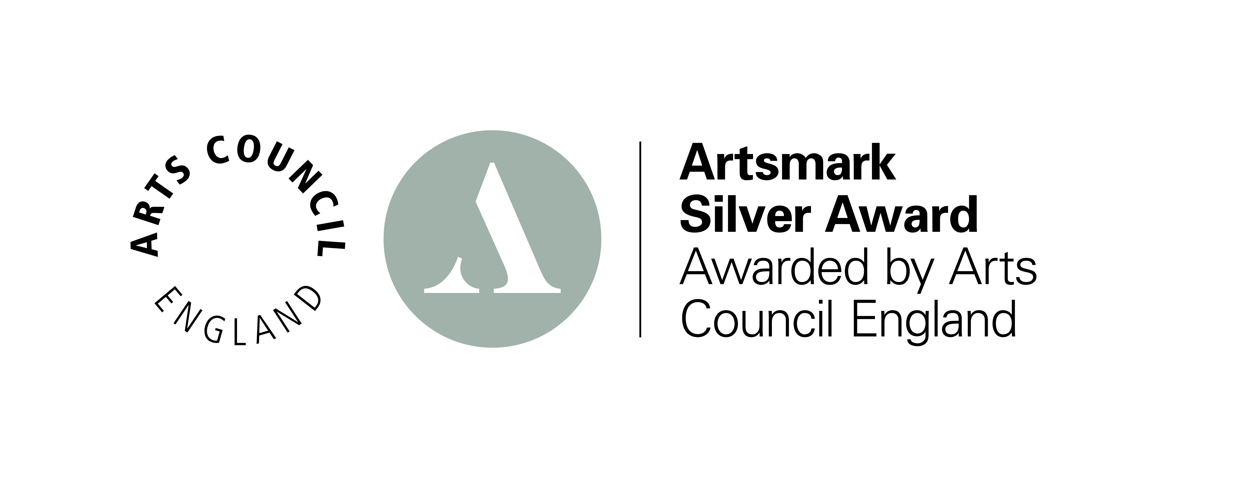
Topic Web Autumn 2020

Reading
Discussing pictures telling a story
Emotions
Phonics
Phase 2 letters and sounds
Beginning to blend and segment simple words
Phase 2 tricky words

Literacy
Letter formation
Listening to and discussing key elements of stories
Name writing
Writing simple words using phase 2 sounds

Numeracy
Recognising and understanding numbers to 10 and then 20
Writing numbers to 10
Ordering numbers
Basic shape recognition

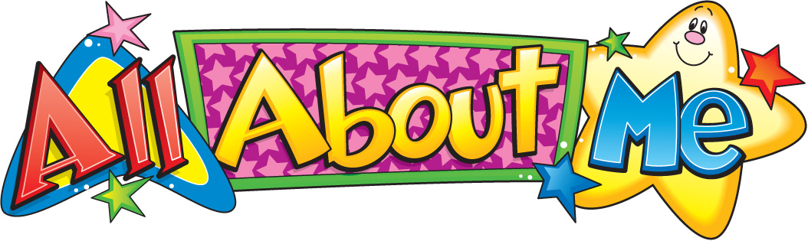

PE
Gross and fine motor skills
Spatial awareness
Using our bodies to create different movements

RE
Creation
I am special
Looking at ourselves, our families
The life of Jesus
Expressive arts & design
Using media and materials to create pictures
Rhythm using percussion
Music to accompany stories
Role play
5 a day

Understanding of the world
All about me
How people help us and the jobs they do
Role play
Using technology - iPads, laptops and cameras



