
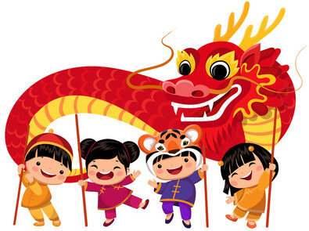




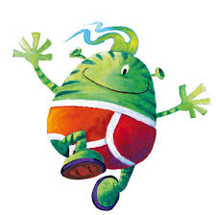
Topic Web Spring 1

Communication & Language
Learn new vocabulary.
Ask questions to find out more and to check they understand what has been said to them.
Articulate their ideas and thoughts in well-formed sentences.
Describe events in some detail.
Listen to and talk about stories to build familiarity and understanding.

Literacy - Phonics & Reading
Phase 3 Monster Phonics
- Form lower-case and capital letters correctly.
- Developing strength with pencil grip and fine motor control.
- Spell words by identifying the sounds and then writing the sound with letter/s
- Begin to write short sentences with words with known sound - letter correspondence
Re-read what they have written to check that it makes sense.
- Engage in non-fiction books.

Reading
Phase 3 Phonics
- Read some letter groups that each represent one sound and say sounds for them
- Read simple phrases and sentences made up of words with known letter–sound correspondences
- Re-read books to build up their confidence in word reading, their fluency and their understanding and enjoyment.

Numeracy
Tentown Numbers
Alive in 5 - Deeper understanding 0-5
Combining two amounts
Subitising
Mass & Capacity
Growing 6, 7, 8 - composition of numbers
Length & height

Expressive arts & design
Rhythm using percussion
Music to accompany stories
Performing songs and stories
Use a variety of materials, tools and techniques in their creations.
Sing a range of well known nursery rhymes
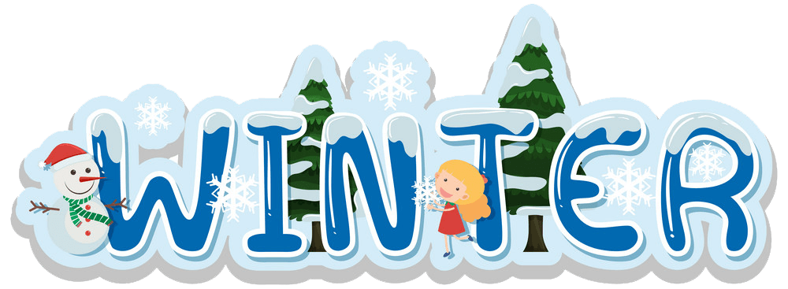




PE

Gross and fine motor skills
Handling small and large equipment
Control and co-ordination
Spatial Awareness

Understanding of the world
Winter - Seasons
Ice/melting/freezing - experimenting
Cold places around the world - Animals that live there
Space - non-fiction
Celebrations - Chinese New Year

RE
Why are some stories special?
Sharing bible stories about Jesus and learning important lessons from them.
Recognise other religions, particularly Islam, and their important stories

