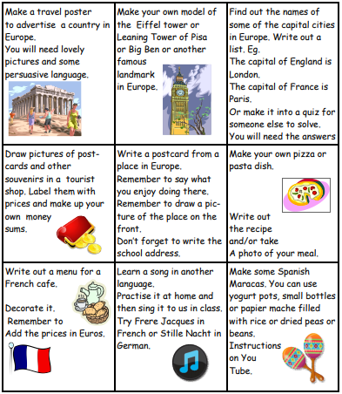

**LOTS OF HOUSE POINTS AND GOLDEN TICKETS ARE AVAILABLE TO WIN FOR FANTASTIC WORK!!!! WILL YOU WIN SOME?**

**Please make sure all work is completed to the best of your ability!**

**Will you impress   
Mrs Duffy, Mrs Ford and Mrs Vivash?**

**Class 3, you produced some brilliant Roman homework this term!**Here is your home learning activities for our new topic that will start in Summer called:   
**EUROPEAN EXPLORERS!**  
You need to choose at least 1 activity to complete.  
All home learning should be brought into school on **Tuesday 25th April** so it can be shared with the class.