ANSON PRIMARY SCHOOL
Class 1 – Week 10
Weekly Learning Tasks
Why have Weekly Learning Tasks been created?
Weekly learning tasks have been created as a result of the ongoing risk of schools shutting due to the Coronavirus outbreak across the UK. Based on this very real and increasing threat. Class teachers have therefore written a set of weekly learning tasks which can be completed by your child whilst schools are closed for a set duration. In creating the weekly learning tasks we fully acknowledge that they cannot replace the quality of learning your child receives at school however, our complete focus has been on creating a set of tasks that all children can access to maximise their learning whilst at home.
What are the aims of the Weekly Learning Tasks?
- To create age specific learning opportunities for primary school children.
- To create a resource for parents that is easy to access and use - the focus is on parents being able to help deliver the content or children accessing it independently.
- Key learning is linked to the Early Years Foundation Stage.
- To enable children to continue with their learning at home during an enforced shutdown.
- To provide structure and focus to each day when an enforced shutdown occurs.
- To centralise online learning resources and links into an easy to manage format for families.
How do I use the Learning Tasks?
As a parent your first step is to read the ideas outlined in this document and choose 1 task from each area to do that day, there is no set time that you should spend on each task as you may wish for your child to spend less or more time on activities.

A mailbox has been set up to receive emails only for any work set outside of the educational programs we use. Please feel free to send work, photographs to your class teacher using the following email address is: anson.class1@tssmat.staffs.sch.uk
We are unable to reply to any emails sent to this address.
If you wish to contact the class teacher please do so as usual by emailing the office email address. anson.office@tssmat.staffs.sch.uk. The class teacher will make every effort to respond within 2 working days.

Online Programs
(Logins for these programs found in the front of your child’s homework diaries)
Bug Club  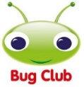 | https://www.activelearnprimary.co.uk/login?c=0  Differentiated Reading Books, which asks your child questions about the texts.
Education City | https://www.educationcity.com/  Age appropriate Literacy and Numeracy Games  Games the teacher has set will be found on your child’s MyCity Page.  We encourage a score of 80% or more, to ‘Pass’ the game.
Purple Mash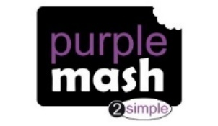 | https://www.purplemash.com/login/  Purple Mash hosts an exciting mash-up of curriculum focused activities. Work the teacher has set can be found on your child’s 2do Page.
Doodlemaths/  Doodletables | https://www.doodlemaths.com/ Also available on the APP Store.  Maths and Times tables Programs.  Work the teacher has set can be found on the ‘extras’ part of the Doodlemaths program.
SpellingShed | https://www.spellingshed.com/en-gb /  Also available on the APP Store Weekly spelling lists are uploaded on this program with activities to try to practise spelling these words.
Teach Your Monster to Read | https://www.teachyourmonstertoread.com/  Also available on the APP Store with age and phonics level appropriate games.
Phonics
Letters and Sounds
https://wandleenglishhub.org.uk/lettersandsounds/reception
On the link above there are daily Phonics lessons that your child can watch and join in with, they are going through each sound and upload a new video every day at 10am.
You can also watch lessons they have previously uploaded if you wanted to choose a specific lesson or sound!
These are extremely helpful lessons to help your child take part in daily phonics.

Class 1 Weekly Learning Tasks Week 10
Weekly Maths Tasks (Aim to do 1 per day) | Weekly Reading Tasks (Aim to do 1 per day)
Maths focus this week: Money  - Complete Maths activities on Education City  - Doodlemaths 5aday and Extras - your child has an individual login to access this.  - Ask your family if you can look inside their wallet or purse or their piggy bank, explore each of the coins, how do they feel, what do they look like? Can you sort the coins from smallest to largest value, talk about why it’s not the shape or the size that makes the coins worth more or less.  - Go to the supermarket or have a look at online shopping at a supermarket, look at the prices of items, you could try and guess how much things are!  - Complete the Piggy Bank worksheet or create your own version. How much is in the piggy bank?  - Complete the Money in the Jar worksheet, for a Chill Challenge can you work out ways to make the different totals, to make 5p you could use 5 pennies or 2x 2ps and a 1p instead of just a 5p coin.  - Create your own shop, use items from around your house, it could be a shop that sells toys, food or whatever you like! Give everything a price tag of - 1p, 2p, 5p, 10p, 20p or £1. You could be the customer or the shop keeper playing with your family using money to pay for the items. | - Children to read to parents daily, reading a book on Bug Club. Complete the questions about the story on each page by clicking on the bugs face on the page.  - Read to your child, you could choose 2 books each day and your child can vote for which book they would like to have read to them. You could even have a whole family vote where everyone votes for the book they would like to hear and then count the votes to see which story has the most.  - Visit Oxford Owl for free eBooks that link to your child’s book band. You can create a free account at Oxford Owl ebook collection. Complete the linked Play activities for each book.  This weeks story:  The Three Little Pigs  I bet you know this story! This story is a Traditional Tale and is very well known! Hopefully you will be able to join in as you read this story. We will be learning the Talk 4 Writing actions too so you can teach yourself these and be able to re-tell the story by yourself! You can watch the Animation story or the ebook (both attached to the Class 1 webpage)
Weekly Phonics Tasks (Aim to do 1 per day) | Weekly Writing Tasks (Aim to do 1 per day)
- Daily Phonics – practise Sounds and Tricky words in Phonics Bag – this week teach your child how to read and write tricky word  > ‘little’  - Watch the videos below each day to recap over a Phase 3 sound, Choose only one sound each day to look at, after the video can you write a list of words with that sound in them.  oo (long)- https://www.youtube.com/watch?v=VQxqTmiDmIQ&feature=youtu.be  oo (short)– https://www.youtube.com/watch?v=McxGM5mU0uM  ar - https://www.youtube.com/watch?v=yVsmYlNXU-k  or – https://www.youtube.com/watch?v=68FTaim0FOQ  - Write words with these sounds in, in a sentence. Don’t forget your capital letters and full stops – if you have practised some of our Phase 4 phonics over the past few weeks you can use these digraphs we are recapping in trickier words with the fast sounds at the start or end!  - Complete Education City phonics activities  - Teach Your Monster to Read – log into your account to practise the sounds and ‘trickies’. | 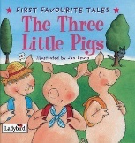  The Three Little Pigs  - Last week you made a story map for the Three Little Pigs, this week your task is to change the story and make it your own, maybe you could have the three little frogs! You could change what houses they build or even change what happens at the end of the story, will it be a happy or sad ending? Use the attached story map to create your own version of the story! Have fun!  - After making your story map, write a sentence to describe something in your new story that you have changed or for a Chilli Challenge write sentences for what happens at the beginning, the middle and the end of your story.  - Write sentences for each of the pictures from the story the Three Little Pigs (attached to the bottom of this document)  - Write words to describe the wolf or the character in your new story, what is the wolf like? (mean, unkind)
Learning Project
to be completed throughout the week
There is a variety of tasks for you to complete throughout the course of the week, you can choose when you do each of these activities and you could even create some activities of your own to do with our topic.

- It’s Father’s Day this Sunday! What does this mean? Why do we have Father’s Day? Make a card to show someone you love and care for them. Think about your design and the colours you choose, think about the person you’re giving the card to, what’s their favourite colour? Whoever you make your card for I am sure they will be very grateful!

- Make stick puppets for your new story of The Three Little Pigs. Act your story out using your puppet theatre that you made.
- Science experiment – can you test out some materials to see which would be the best to build a house out of? You could use anything from around your house and see which are the strongest or the easiest to build with or easiest to join together to make it stronger. Discuss what you find out about these materials with your family.

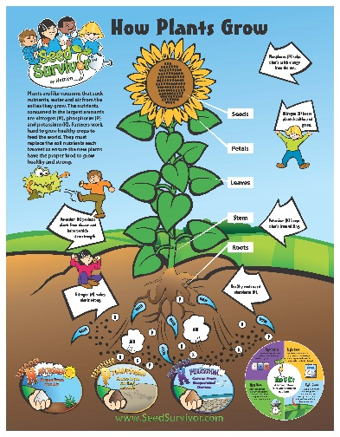
- Planting & Growing – go into your garden (or on a walk) and look at the plants, even the weeds! What can you see on the plants? Look carefully at the different parts you can see, what do they all do? Take pictures of each part of the plant and then you can zoom in to look at them in more detail
Can you find and take pictures of the;
- Stem
- Leaves
- Petals
- Buds
- Roots
- Anther

- Look after and care for the plants in your garden, what do plants need to grow? Watch this video to find out what plants need to grow.
BBC Teach https://www.youtube.com/watch?v=_RXVhiUnTA8&t=32s

- Complete the activities on Purplemash : Garden Centres and Flowers

PE
- Joe Wicks Live PE Lessons each morning at 9 am.

- Go Noodle with the family or have a family workout.

- Cosmic Yoga videos are lots of fun!

- Can you create your own work out for your family? You could make an obstacle course in your house or in the garden, you could time each of your family members to see who completes it the fastest.
Useful Websites
- Oxford Owl for home - https://www.oxfordowl.co.uk/
Providing free access to online books for parents

- Twinkl – https://www.twinkl.co.uk/
Providing free access to home learning packs

- Phonics Play – https://www.phonicsplay.co.uk/
A fantastic website for your child to independently access phonics games where you can select specific sounds or tricky words to focus on. Currently providing a free login in march to access from home.

- Story Online – https://www.storylineonline.net/
Access to a wide variety of books read aloud for your child to listen to

- Vooks - https://www.vooks.com/
Access to a wide variety of books – currently free

- Sky Writer - https://www.ictgames.com/mobilePage/skyWriter/index.html
Cursive hand-writing practice

- Phonics Bloom - https://www.phonicsbloom.com/

- BBC Supermovers - https://www.bbc.co.uk/teach/supermovers

- Topmarks - https://www.topmarks.co.uk/Search.aspx?Subject=37
A website full of interactive games

- ICT Games - http://www.ictgames.com/
A website full of interactive games

-Lalilo - https://www.lalilo.com/
This site is completely free to sign up to and use at the moment. It is full of Phonics and Reading games that you can use with your child.

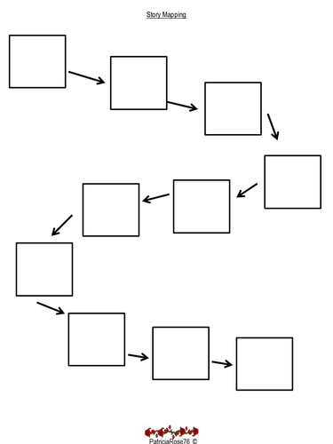
The Three Little Pigs – Story Map

