ANSON PRIMARY SCHOOL
Class 1 – Week 3
Weekly Learning Tasks
Why have Weekly Learning Tasks been created?
Weekly learning tasks have been created as a result of the ongoing risk of schools shutting due to the Coronavirus outbreak across the UK. Based on this very real and increasing threat. Class teachers have therefore written a set of weekly learning tasks which can be completed by your child whilst schools are closed for a set duration. In creating the weekly learning tasks we fully acknowledge that they cannot replace the quality of learning your child receives at school however, our complete focus has been on creating a set of tasks that all children can access to maximise their learning whilst at home.
What are the aims of the Weekly Learning Tasks?
- To create age specific learning opportunities for primary school children.
- To create a resource for parents that is easy to access and use - the focus is on parents being able to help deliver the content or children accessing it independently.
- Key learning is linked to the Early Years Foundation Stage.
- To enable children to continue with their learning at home during an enforced shutdown.
- To provide structure and focus to each day when an enforced shutdown occurs.
- To centralise online learning resources and links into an easy to manage format for families.
How do I use the Learning Tasks?
As a parent your first step is to read the ideas outlined in this document and choose 1 task from each area to do that day, there is no set time that you should spend on each task as you may wish for your child to spend less or more time on activities.

A mailbox has been set up to receive emails only for any work set outside of the educational programs we use. Please feel free to send work, photographs to your class teacher using the following email address is: anson.class1@tssmat.staffs.sch.uk
We are unable to reply to any emails sent to this address.
If you wish to contact the class teacher please do so as usual by emailing the office email address. anson.office@tssmat.staffs.sch.uk. The class teacher will make every effort to respond within 2 working days.

Online Programs
(Logins for these programs found in the front of your child’s homework diaries)
Bug Club  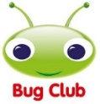 | https://www.activelearnprimary.co.uk/login?c=0  Differentiated Reading Books, which asks your child questions about the texts.
Education City | https://www.educationcity.com/  Age appropriate Literacy and Numeracy Games  Games the teacher has set will be found on your child’s MyCity Page.  We encourage a score of 80% or more, to ‘Pass’ the game.
Purple Mash | https://www.purplemash.com/login/  Purple Mash hosts an exciting mash-up of curriculum focused activities. Work the teacher has set can be found on your child’s 2do Page.
Doodlemaths/  Doodletables | https://www.doodlemaths.com/ Also available on the APP Store.  Maths and Times tables Programs.  Work the teacher has set can be found on the ‘extras’ part of the Doodlemaths program.
SpellingShed | https://www.spellingshed.com/en-gb /  Also available on the APP Store Weekly spelling lists are uploaded on this program with activities to try to practise spelling these words.
Teach Your Monster to Read | https://www.teachyourmonstertoread.com/  Also available on the APP Store with age and phonics level appropriate games.

Class 1 Weekly Learning Tasks Week 3
Weekly Maths Tasks (Aim to do 1 per day) | Weekly Reading Tasks (Aim to do 1 per day)
Maths focus this week: Doubling  - Watch a Numberblocks Clip each day at BBC or Cbeebies. Use this guide here to give you ideas on what to do with your children whilst watching an episode.  - Doodlemaths 5aday and Extras - your child has an individual login to access this.  - Complete Maths Share Bears on Education City – can you learn about doubling and halving by moving the bears to help find the answer?  - Using objects from around your house can you create a ‘doubling machine’ – make this so you can add an amount into one side and then when you press the button and collect the items you need to double them!  - Make a ladybirds back out – you could colour this onto paper or make a large one out of cardboard. Cut out lots of ladybird spots. Choose an amount of spots to place on one side, then double it and put the same amount of spots of the other side. Write your number sentences down e.g. 4+4=8 | - Children to read to parents daily, reading a book on Bug Club. Complete the questions about the story on each page by clicking on the bugs face on the page.  - Read to your child, you could choose 2 books each day and your child can vote for which book they would like to have read to them. You could even have a whole family vote where everyone votes for the book they would like to hear and then count up the votes to see which story has the most.  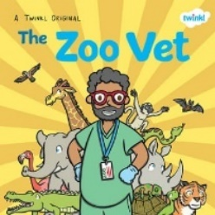  - Visit Oxford Owl for free eBooks that link to your child’s book band. You can create a free account at Oxford Owl ebook collection. Complete the linked Play activities for each book..  - Read the Twinkl Story – ‘The Zoo Vet’ (this has been added to the documents on the Class page)  - Talk about this story together, ask your child questions throughout to see their understanding and comprehension on the story.
Weekly Phonics Tasks (Aim to do 1 per day) | Weekly Writing Tasks (Aim to do 1 per day)
- Daily Phonics - practise Sounds and Tricky words in Phonics Bag – this week teach your child how to read and write tricky words  ‘like’ & ‘so’  - Introduce Polysyllabic Words to your child – this is where they add two words together to make one word e.g. car+pet = carpet. Write down some for them to read or write the word split up on two separate bits of paper can they push them together to make a word.  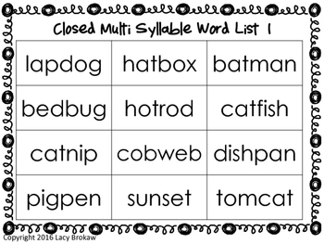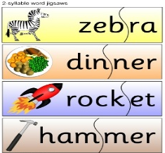  - Use your sounds in your Phonics Bag to make words to blend out loud – have a go at writing these once you have read them  - Complete Education City > My City > variety of activities  - Teach Your Monster to Read – log into your account to practise the sounds and ‘trickies’ you are currently learning.  - Complete Phonics 2Dos Activity on Purplemash – Cloze – Polysyllabic Words Phonics game, adding two words together to make one word, read the word out loud to make sure it makes sense, can you explain what that word means?  - Go to Phonics Play website > Dragons Den > Polysyllabic Words or CVCC set 1-7 | - Choose a set of these sounds to write as many words you can think of that contain this sound, you could look around your house or find a pictures from the internet. For an extra challenge can you write a sentence with these words in?  - ee, oo, ng  or  - air, ure, ear  - Tricky words – said, have, like, so – write sentences using these tricky words.  - Practice your cursive handwriting by choosing each letter on Cursive Sky Writer and writing it on a piece of paper. Don’t forget your lead ins and lead outs.  - After reading the story ‘The Zoo Vet’ – can you write 2 sentences to describe the animals the vet treats in the story > Giraffe, Flamingo, Chameleon, Elephant, Tiger. For an extra challenge can you use the word ‘and’ in your sentence to make it a longer and stronger sentence?  - The Zoo Vet treats lots of different animals, can you write your own page for the story? Use your favourite animal and write simple sentences to describe what is wrong with your animal. You could give your animal a name, I would call mine Polly the Panda!  Don’t forget to use Capital letters, Finger spaces  and Full stops in your sentences!
Learning Project – to be done throughout the week - Animals
The project this week aims to provide opportunities for your child to learn more about the topic Animals. Below there is a variety of tasks for you to complete throughout the course of the week, you can choose when you do each of these activities and you could even create some activities of your own to do with our topic.

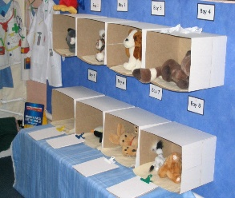
- Create your own Vets roleplay area in your home – I have missed setting up Class 1’s roleplay area ready for our new term, so I thought you could create your own at home! You can fill your vets with your teddys and stuffed animals or even create your own animals or pictures and pretend they are your patients! You could make your own clipboard and have paper to write down what is wrong with your patients and how you can treat them. There are lots of examples of ‘Vets roleplay areas for EYFS’ on the internet so have an explore and make a list of what you will need in your roleplay area! I can’t wait to see them!

- Research all about vets, what do they do? How is there job important? Are Vets classed as key workers at the moment, do you know about key workers - what does this mean?

- Our story focus this week is the ‘The Zoo Vet’ – What activities can you do around this story
- Can you make masks for the animals in the story? You could make one for each of your family members and act as those animals!
- Make your own ‘Zoo Small World Area’ from items in your house.
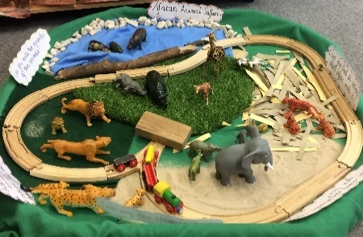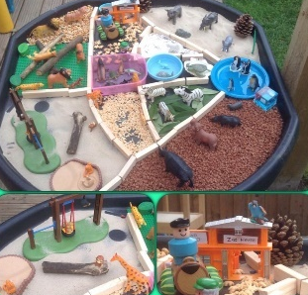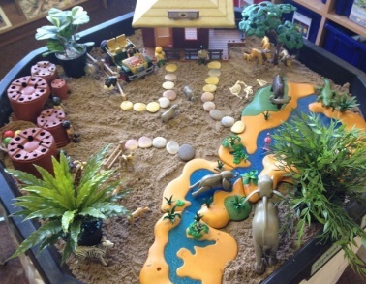
- What other stories can you find that have zoo animals in them? Read and discuss them with your family.

- Research what types of animals live in a zoo, how are they looked after? Why are animals kept in zoos? Write down what you find out!

- Catch up on the Virtual Zoo at Chester Zoo – you can watch lots of different videos here > Chester Zoo - Youtube link that were made at Chester Zoo for some of the animals they have there, from Red Pandas to Asian Elephants! The Zoo keepers tell you all about feeding them, how they look after them and all about what the animals do, you also get to look all around their enclosures (which will help you for this activity below).
- If you have a search on the internet you will also find Zoos from around the world showing their animals on live webcams throughout the day, so you can enjoy a trip to the zoo from your home!

- Draw your own Zoo and create different areas for the different animals. Research what kind of enclosures they might need, what do they need inside them? Do they need somewhere to swim? How tall does the enclosure need to be and why does it need to be this tall? Can the animal fly, does the enclosure need a net to stop them flying away? Do they need tall trees to swing from?
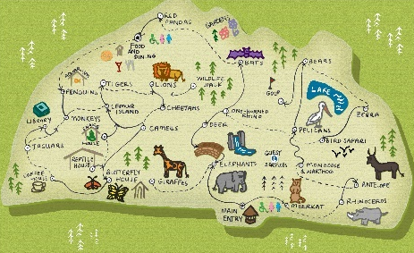
- Make a map to go with your zoo that you would give to people so they can navigate around your zoo.
- Play the Zoo Pairs game on Purplemash, there are lots of different animals that you need to match to it’s pair!
- Complete the activities for our Animal topic on Education City – these activities are all about farmyard animals. Can you select the correct animal and choose the matching sound they make?
Expressive Arts & Design and Music
Music – Can you learn the song ‘We’re going to the Zoo’?
Here is a video > We're going to the Zoo - Youtube where you can listen and join in with the song. On this video you can also learn the Singing Hands – Makaton actions for this song and you can copy the actions as the song goes on. These actions involve symbols and signs as a language to help people communicate – just like when we say our prayers at school. Maybe you could teach your family the signs you already know for our prayer?

PE
- Joe Wicks Live PE Lessons each morning at 9 am.

- Go Noodle with the family or have a family workout.

- Cosmic Yoga videos are lots of fun!

- Can you create your own work out for your family? You could make an obstacle course in your house or in the garden, you could time each of your family members to see who completes it the fastest.
Useful Websites
- Oxford Owl for home - https://www.oxfordowl.co.uk/
Providing free access to online books for parents

- Twinkl – https://www.twinkl.co.uk/
Providing free access to home learning packs

- Phonics Play – https://www.phonicsplay.co.uk/
A fantastic website for your child to independently access phonics games where you can select specific sounds or tricky words to focus on. Currently providing a free login in march to access from home.

- Story Online – https://www.storylineonline.net/
Access to a wide variety of books read aloud for your child to listen to

- Vooks - https://www.vooks.com/
Access to a wide variety of books – currently free

- Sky Writer - https://www.ictgames.com/mobilePage/skyWriter/index.html
Cursive hand-writing practice

- Phonics Bloom - https://www.phonicsbloom.com/

- BBC Supermovers - https://www.bbc.co.uk/teach/supermovers

- Topmarks - https://www.topmarks.co.uk/Search.aspx?Subject=37
A website full of interactive games

- ICT Games - http://www.ictgames.com/
A website full of interactive games

-Lalilo - https://www.lalilo.com/
This site is completely free to sign up to and use at the moment. It is full of Phonics and Reading games that you can use with your child.

