ANSON PRIMARY SCHOOL
Class 1 – Week 4
Weekly Learning Tasks
Why have Weekly Learning Tasks been created?
Weekly learning tasks have been created as a result of the ongoing risk of schools shutting due to the Coronavirus outbreak across the UK. Based on this very real and increasing threat. Class teachers have therefore written a set of weekly learning tasks which can be completed by your child whilst schools are closed for a set duration. In creating the weekly learning tasks we fully acknowledge that they cannot replace the quality of learning your child receives at school however, our complete focus has been on creating a set of tasks that all children can access to maximise their learning whilst at home.
What are the aims of the Weekly Learning Tasks?
- To create age specific learning opportunities for primary school children.
- To create a resource for parents that is easy to access and use - the focus is on parents being able to help deliver the content or children accessing it independently.
- Key learning is linked to the Early Years Foundation Stage.
- To enable children to continue with their learning at home during an enforced shutdown.
- To provide structure and focus to each day when an enforced shutdown occurs.
- To centralise online learning resources and links into an easy to manage format for families.
How do I use the Learning Tasks?
As a parent your first step is to read the ideas outlined in this document and choose 1 task from each area to do that day, there is no set time that you should spend on each task as you may wish for your child to spend less or more time on activities.

A mailbox has been set up to receive emails only for any work set outside of the educational programs we use. Please feel free to send work, photographs to your class teacher using the following email address is: anson.class1@tssmat.staffs.sch.uk
We are unable to reply to any emails sent to this address.
If you wish to contact the class teacher please do so as usual by emailing the office email address. anson.office@tssmat.staffs.sch.uk. The class teacher will make every effort to respond within 2 working days.

Online Programs
(Logins for these programs found in the front of your child’s homework diaries)
Bug Club | https://www.activelearnprimary.co.uk/login?c=0  Differentiated Reading Books, which asks your child questions about the texts.
Education City | https://www.educationcity.com/  Age appropriate Literacy and Numeracy Games  Games the teacher has set will be found on your child’s MyCity Page.  We encourage a score of 80% or more, to ‘Pass’ the game.
Purple Mash | https://www.purplemash.com/login/  Purple Mash hosts an exciting mash-up of curriculum focused activities. Work the teacher has set can be found on your child’s 2do Page.
Doodlemaths/  Doodletables | https://www.doodlemaths.com/ Also available on the APP Store.  Maths and Times tables Programs.  Work the teacher has set can be found on the ‘extras’ part of the Doodlemaths program.
SpellingShed | https://www.spellingshed.com/en-gb /  Also available on the APP Store Weekly spelling lists are uploaded on this program with activities to try to practise spelling these words.
Teach Your Monster to Read | https://www.teachyourmonstertoread.com/  Also available on the APP Store with age and phonics level appropriate games.

Class 1 Weekly Learning Tasks Week 4
Weekly Maths Tasks (Aim to do 1 per day) |  | Weekly Reading Tasks (Aim to do 1 per day)
Maths focus this week: Subtraction  We have looked at Subtraction before at school but just to remind you watch this video https://www.youtube.com/watch?v=GdXClek-05I  - Watch a Numberblocks Clip each day at BBC or Cbeebies. Use this guide here to give you ideas on what to do with your children whilst watching an episode.  - Doodlemaths 5aday and Extras - your child has an individual login to access this.  - Complete Maths Hop Off on Education City – can you write the subtraction number sentences for each of the questions as you play - for an extra challenge? (I have also added an extra challenge task if you are feeling like a Maths Magician this week!)  - Can you act out the subtraction number sentences (at the bottom of the page – choose 1 of the sets of questions) by using objects or you could use your fingers or count back in your head! Don’t forget when we take away the number gets smaller!  - Subtraction game – using teddy bears – put items/sweets/food on a plate for your teddy (up to 10), pretend your teddy eats some of them – how many are left? Write your number sentences down (5-2=3).  - Subtraction Word Problems – (at the bottom of the page) Can you work out the problems, you can use objects to help you find the answer, listen carefully to an adult reading out the problem, listen for the numbers you need. Write the number sentence to your word problem. Good luck! |  | - Children to read to parents daily, reading a book on Bug Club. Complete the questions about the story on each page by clicking on the bugs face on the page.  - Read to your child, you could choose 2 books each day and your child can vote for which book they would like to have read to them. You could even have a whole family vote where everyone votes for the book they would like to hear and then count up the votes to see which story has the most.  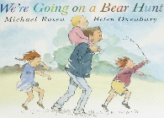  - Visit Oxford Owl for free eBooks that link to your child’s book band. You can create a free account at Oxford Owl ebook collection. Complete the linked Play activities for each book..  - Read or watch the story We’re Going on a Bear Hunt by Michael Rosen  https://www.youtube.com/watch?v=Waoa3iG3bZ4  - Now watch Michael Rosens story with actions, join in with the actions, practice everyday and use your story map and see if you can remember the whole story by the end of the week!  https://www.youtube.com/watch?v=0gyI6ykDwds
Weekly Phonics Tasks (Aim to do 1 per day) | Weekly Writing Tasks (Aim to do 1 per day)
- Daily Phonics - practise Sounds and Tricky words in Phonics Bag – this week teach your child how to read and write tricky words > ‘come’ & ‘some’  - Phase 3 – we completed phase 3 before we finished school and have been recapping the sounds. Please go through all of the Phase 3 sounds and check which ones your child is still unsure of and continue to practise these sounds daily.  - Introduce Phase 4 with your child – the green sheet in your child’s phonics bag has these sounds on.  This video shows how you pronounce Phase 4 sounds which I thought would be helpful for parents too! https://www.youtube.com/watch?v=VR_IgfIgz10  - We are going to be looking at the fast blends at the end of words >this video will show you how to blend this together to read the word  https://www.youtube.com/watch?v=k-1rmuOxGE8&list=PLXKeximRDJ8o6dY-pCsIwtJzD_NyGZltL&index=3&t=0s  st > https://www.youtube.com/watch?v=mPtYpqEwEHo  - Use your sounds in your Phase 2 and Phase 3 cards in your Phonics Bag to make words to blend out loud – have a go at writing these once you have read them e.g. t/e/n/t = tent h/a/n/d = hand ch/a/m/p = champ  - Complete Education City > My City > variety of activities  - Teach Your Monster to Read – log into your account to practise the sounds and ‘trickies’.  - Go to Phonics Play website > Phase 4 > Make a Match | We’re Going on a Bear Hunt by Micheal Rosen  - Can you make your own Story Map for our story this week – drawing pictures and labelling each step? At the bottom of this page I have added a large version of an example story map and a template you could print or create your own version. A story map helps you to remember the main parts to the story so that you can re-tell it.  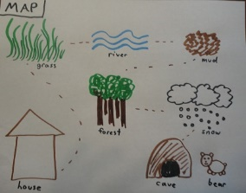  - Can you describe the things the family go through on their journey. Write a sentence for each to describe what it would have felt like. E.g. The mud is thick and cold. To help you remember your sentence and to listen out for the next word you could record yourself saying the sentence on a phone and play it back (like our talking tins at school!) Or you could write words to describe each place they go through – thick, brown, wet.  - Can you remember the story you have read? Use your phonetic knowledge to write down the phrases from the story e.g. “We can’t go over it, we can’t go under it. Oh no we’ve got to go through it.”  Don’t forget to use Capital letters, Finger spaces  and Full stops in your sentences!
Learning Project – to be done throughout the week - Animals
The project this week aims to provide opportunities for your child to learn more about the topic Animals. Below there is a variety of tasks for you to complete throughout the course of the week, you can choose when you do each of these activities and you could even create some activities of your own to do with our topic.
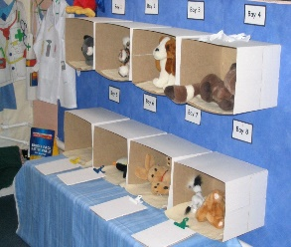

- Your Vets roleplay areas look amazing, keep using them this week. You may want to add to your roleplay area to enhance it this week. You could label items in your roleplay, write lists of equipment you have, create pretend x-ray pictures! Have fun!

- Create your own Bear from the We’re Going on a Bear Hunt story on Purplemash 2Dos. Will you make a big and scary bear? Or will yours be a little and fluffy bear? What colours will you choose? Why did you choose those colours?

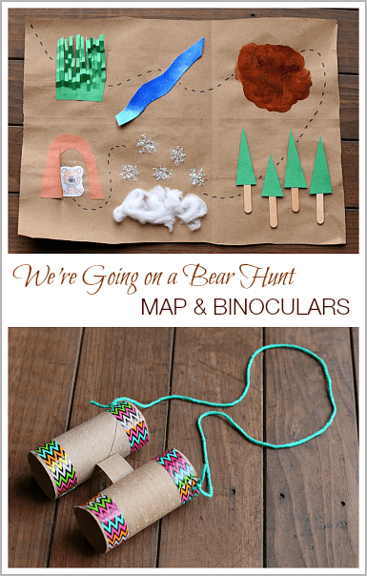
- Change your Zoo Small World area to a We’re Going on a Bear Hunt one. You could do this outside, using soil, grass, sticks, ice cubes!
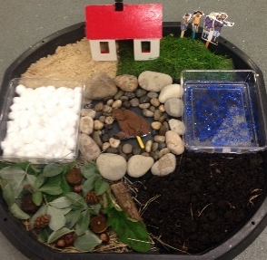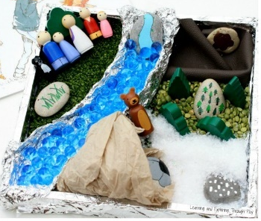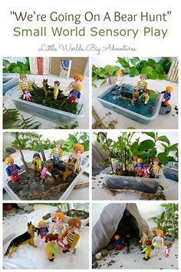
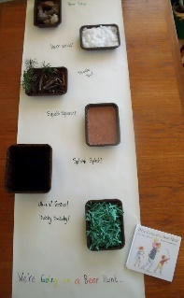
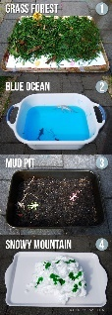
- Make your own stick puppets for the family on We’re Going on a Bear Hunt and add these to your small world area to act out the story!

- Create your own bare foot sensory walk for our story this week in your garden. Walk through each of the tubs or sections you have made – you could make the noises as you walk through…squelch squerch!

- Research all about Bears, find out facts about different types of bears, what countries they live in, what do they eat, what types of habitats do they live in? You could find videos that give you lots of information about bears or read through the Bear Facts PowerPoint file in the documents on the class page. You could make a poster about the bears you find out about or draw the different bears.

- Have a teddy bears picnic in your garden with your family and lots of teddy bears! Make invitations for who will be at your picnic for your family and bears. You could make a list of everything you want at your picnic and find it in your home or make a shopping list. You can help to prepare the picnic making sandwiches, pouring drinks or carefully cutting up fruit with an adult and helping to tidy and wash up afterwards! Enjoy your picnic.
Expressive Arts & Design and Music
Music – Can you learn the song ‘Teddy Bears Picnic’ – you could sing this song when you have your teddys bears picnic!
https://www.youtube.com/watch?v=YDndFOtBy-E

A listening challenge for you this week - Can you guess the sound https://www.youtube.com/watch?v=n1m4h79JZso - watch the video, listening carefully to the sounds, can you guess what is making that sound. You could make your own after by choosing something in your house that makes a noise or tapping an object onto something so that it makes a noise whilst someone else has their eyes closed and they need to guess what the object is making the sound!

PE
- Joe Wicks Live PE Lessons each morning at 9 am.

- Go Noodle with the family or have a family workout.

- Cosmic Yoga videos are lots of fun!

- Can you create your own work out for your family? You could make an obstacle course in your house or in the garden, you could time each of your family members to see who completes it the fastest.
Useful Websites
- Oxford Owl for home - https://www.oxfordowl.co.uk/
Providing free access to online books for parents

- Twinkl – https://www.twinkl.co.uk/
Providing free access to home learning packs

- Phonics Play – https://www.phonicsplay.co.uk/
A fantastic website for your child to independently access phonics games where you can select specific sounds or tricky words to focus on. Currently providing a free login in march to access from home.

- Story Online – https://www.storylineonline.net/
Access to a wide variety of books read aloud for your child to listen to

- Vooks - https://www.vooks.com/
Access to a wide variety of books – currently free

- Sky Writer - https://www.ictgames.com/mobilePage/skyWriter/index.html
Cursive hand-writing practice

- Phonics Bloom - https://www.phonicsbloom.com/

- BBC Supermovers - https://www.bbc.co.uk/teach/supermovers

- Topmarks - https://www.topmarks.co.uk/Search.aspx?Subject=37
A website full of interactive games

- ICT Games - http://www.ictgames.com/
A website full of interactive games

-Lalilo - https://www.lalilo.com/
This site is completely free to sign up to and use at the moment. It is full of Phonics and Reading games that you can use with your child.
