ANSON PRIMARY SCHOOL
Class 1 – Week 5
Weekly Learning Tasks
Why have Weekly Learning Tasks been created?
Weekly learning tasks have been created as a result of the ongoing risk of schools shutting due to the Coronavirus outbreak across the UK. Based on this very real and increasing threat. Class teachers have therefore written a set of weekly learning tasks which can be completed by your child whilst schools are closed for a set duration. In creating the weekly learning tasks we fully acknowledge that they cannot replace the quality of learning your child receives at school however, our complete focus has been on creating a set of tasks that all children can access to maximise their learning whilst at home.
What are the aims of the Weekly Learning Tasks?
- To create age specific learning opportunities for primary school children.
- To create a resource for parents that is easy to access and use - the focus is on parents being able to help deliver the content or children accessing it independently.
- Key learning is linked to the Early Years Foundation Stage.
- To enable children to continue with their learning at home during an enforced shutdown.
- To provide structure and focus to each day when an enforced shutdown occurs.
- To centralise online learning resources and links into an easy to manage format for families.
How do I use the Learning Tasks?
As a parent your first step is to read the ideas outlined in this document and choose 1 task from each area to do that day, there is no set time that you should spend on each task as you may wish for your child to spend less or more time on activities.

A mailbox has been set up to receive emails only for any work set outside of the educational programs we use. Please feel free to send work, photographs to your class teacher using the following email address is: anson.class1@tssmat.staffs.sch.uk
We are unable to reply to any emails sent to this address.
If you wish to contact the class teacher please do so as usual by emailing the office email address. anson.office@tssmat.staffs.sch.uk. The class teacher will make every effort to respond within 2 working days.

Online Programs
(Logins for these programs found in the front of your child’s homework diaries)
Bug Club | https://www.activelearnprimary.co.uk/login?c=0  Differentiated Reading Books, which asks your child questions about the texts.
Education City | https://www.educationcity.com/  Age appropriate Literacy and Numeracy Games  Games the teacher has set will be found on your child’s MyCity Page.  We encourage a score of 80% or more, to ‘Pass’ the game.
Purple Mash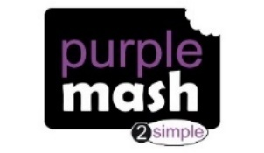 | https://www.purplemash.com/login/  Purple Mash hosts an exciting mash-up of curriculum focused activities. Work the teacher has set can be found on your child’s 2do Page.
Doodlemaths/  Doodletables | https://www.doodlemaths.com/ Also available on the APP Store.  Maths and Times tables Programs.  Work the teacher has set can be found on the ‘extras’ part of the Doodlemaths program.
SpellingShed | https://www.spellingshed.com/en-gb /  Also available on the APP Store Weekly spelling lists are uploaded on this program with activities to try to practise spelling these words.
Teach Your Monster to Read | https://www.teachyourmonstertoread.com/  Also available on the APP Store with age and phonics level appropriate games.

Class 1 Weekly Learning Tasks Week 5
Weekly Maths Tasks (Aim to do 1 per day) |  | Weekly Reading Tasks (Aim to do 1 per day)
Maths focus this week: 2D and 3D Shapes  Listen to these catchy shape songs! They might help you to remember them!  2D shape song - https://www.youtube.com/watch?v=WTeqUejf3D0  3D shape song - https://www.youtube.com/watch?v=guNdJ5MtX1A  - Doodlemaths 5aday and Extras - your child has an individual login to access this.  - Complete Maths shape activities on Education City  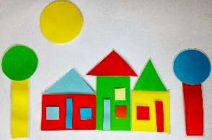  - Make a 2D shape picture, cut out paper into shapes – square, triangle, circle and rectangle and make these into a picture. Can you describe each shape as you build your picture?  - Go on a shape hunt around your home – look for objects that are 3D shapes – make a list, draw the objects e.g. football = sphere, candle = cylinder etc.  - Look at 3D shapes in your home search together to see what you can find, cereal boxes, pringles tubes, football, dice – Sphere, cube, cuboid, cylinder, pyramid, cone – describe the 3D shapes to each other look at how they are different to 2D shapes, 3D shapes are fat and 2D shapes are flat. What 2D shapes can you see on them e.g on a cuboid you can see squares and rectangles.  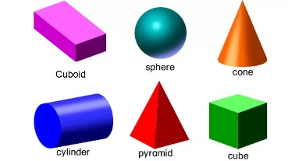  - Using your 3D shapes you have found, play a game – put a blindfold on and pick up a shape by feeling it can you tell what the shape is, or to make it more of a challenge get someone else to describe the shape whilst you have your eyes closed, can you guess what it is? |  | - Children to read to parents daily, reading a book on Bug Club. Complete the questions about the story on each page by clicking on the bugs face on the page.  - Read to your child, you could choose 2 books each day and your child can vote for which book they would like to have read to them. You could even have a whole family vote where everyone votes for the book they would like to hear and then count the votes to see which story has the most.  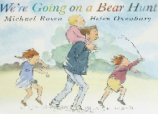  - Visit Oxford Owl for free eBooks that link to your child’s book band. You can create a free account at Oxford Owl ebook collection. Complete the linked Play activities for each book.  - Read or watch the story We’re Going on a Bear Hunt by Michael Rosen (with actions)  https://www.youtube.com/watch?v=0gyI6ykDwds  Can you create your own We’re Going on a Bear Hunt? You could do this in your home, it does not even need to be to find a bear, you could choose your own animal/thing you are going to hunt. I might go on a Mole Hunt as there is lots of mole hills in a field near to my house! I will decide what places I will need to go through to go on my mole hunt and act it out! You can do this just around your home, in your garden or on a short walk.
Weekly Phonics Tasks (Aim to do 1 per day) | Weekly Writing Tasks (Aim to do 1 per day)
- Daily Phonics - practise Sounds and Tricky words in Phonics Bag – this week teach your child how to read and write tricky word > ‘do’  - Phase 3 – we completed phase 3 before we finished school and have been recapping the sounds. Please go through all of the Phase 3 sounds and check which ones your child is still unsure of and continue to practise these sounds daily.  - Continue to look at fast blends at the end of words > this video will show you how to blend more fast blends to read the word  https://www.youtube.com/watch?v=eCVcdFN-Ov0&list=PLXKeximRDJ8o6dY-pCsIwtJzD_NyGZltL&index=3  - Use your sounds in your Phase 2 and Phase 3 cards in your Phonics Bag to make words to blend out loud – have a go at writing these once you have read them e.g. b/u/l/k = bulk l/a/m/p = lamp  - Make your own or print the Phoneme Frames with 4 squares (see end of document for this) write your own 4 letter words in these or use the Phase 4 pictures at the bottom of this document, remember 1 phoneme = 1 box  - Complete Education City > My City > variety of activities  - Teach Your Monster to Read – log into your account to practise the sounds and ‘trickies’. | We’re Going on a Bear Hunt by Micheal Rosen  - You should have created your own We’re Going on a Bear Hunt where you have changed the places you go through or even changed the bear! Can you show your new story on a new Story Map – draw pictures of where you go, write labels by each one to explain what it is.  E.g - down the stairs *creak creak* » through the living room *stomp stomp*» over the lego *crunch crunch* » into the garden *squelch squelch* round the flower bed *tip toe tip toe* » into the shed *crash bang* etc…  - Can you write the words you said to describe the sound you made through each area of your new Bear Hunt – stomp stomp.  - Order pictures of the areas you went through on your hunt (you could draw your own of each place or print them off) Write labels for objects you can see in each area e.g. in the living room – rug, chair, lamp, mug,  - Draw a picture and label who is going to go on your hunt with you.  - Label your animal/object you are going on a hunt for – e.g. We’re going on a MOLE hunt – black fur, pink nose, sharp claws, long tail, long whiskers. If you want an extra challenge you could write a sentence to describe each feature!
Learning Project – to be done throughout the week - Animals
The project this week aims to provide opportunities for your child to learn more about the topic Animals. Below there is a variety of tasks for you to complete throughout the course of the week, you can choose when you do each of these activities and you could even create some activities of your own to do with our topic.

- Nocturnal Animals – find out all about animals that are awake during the night. Draw or list these animals that you find out about. You might want to find out about;
- where they live
- what they do
- what they eat
- what helps them survive at night

- Pretend you are a nocturnal animal, turn the lights off and shut your curtains, make it feel like you are awake at night time, you could build tunnels/chambers/dens using cushions and sheets, is it tricky to move around these things you have made when it is dark? You might find yourself feeling around to find where to crawl or move to! It is tricky isn’t it!

- Day and night sorting activity – now you have found out about nocturnal animals, can you sort these animals into ones that are awake in the day or the night? If you are not sure, then find out as you go along!
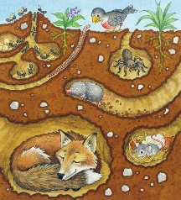
- Find out more about these animals > badgers, foxes, moles, rabbits – these animals all create homes underground. Find out how and why they do this and what we call the home they make. On BBC Teach on this link below, there are some videos all about these animals, you can watch bits of these to show you what it looks like in their underground tunnels! (you can watch them all or skip through parts of them, they are just an idea to show you what they are like!)
https://www.bbc.co.uk/teach/class-clips-video/science-ks1-ks2-the-burrowers/z74kgwx

- Look at the similarities and differences between these animals – the colour of their fur, their bodies, how they live, how they move, what they eat. Talk about this with your family.

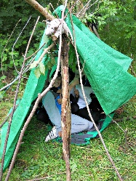
- Go on a woodland walk and see if you can see any places you think rabbits, foxes, badgers, moles might have been, you might see the holes and openings to their homes or you might see footprints or even mounds of mud… I wonder which animal that might be! Take pictures of what you find!

- Make your own underground den – Well …we can’t dig tunnels underground to make a den, but you could build your own den in your garden or in the woods. Have fun!

- Create a picture of a fox, mole, rabbit or badger – you could use paints, crayons or a variety of materials!

PE
- Joe Wicks Live PE Lessons each morning at 9 am.

- Go Noodle with the family or have a family workout.

- Cosmic Yoga videos are lots of fun!

- Can you create your own work out for your family? You could make an obstacle course in your house or in the garden, you could time each of your family members to see who completes it the fastest.
Useful Websites
- Oxford Owl for home - https://www.oxfordowl.co.uk/
Providing free access to online books for parents

- Twinkl – https://www.twinkl.co.uk/
Providing free access to home learning packs

- Phonics Play – https://www.phonicsplay.co.uk/
A fantastic website for your child to independently access phonics games where you can select specific sounds or tricky words to focus on. Currently providing a free login in march to access from home.

- Story Online – https://www.storylineonline.net/
Access to a wide variety of books read aloud for your child to listen to

- Vooks - https://www.vooks.com/
Access to a wide variety of books – currently free

- Sky Writer - https://www.ictgames.com/mobilePage/skyWriter/index.html
Cursive hand-writing practice

- Phonics Bloom - https://www.phonicsbloom.com/

- BBC Supermovers - https://www.bbc.co.uk/teach/supermovers

- Topmarks - https://www.topmarks.co.uk/Search.aspx?Subject=37
A website full of interactive games

- ICT Games - http://www.ictgames.com/
A website full of interactive games

-Lalilo - https://www.lalilo.com/
This site is completely free to sign up to and use at the moment. It is full of Phonics and Reading games that you can use with your child.

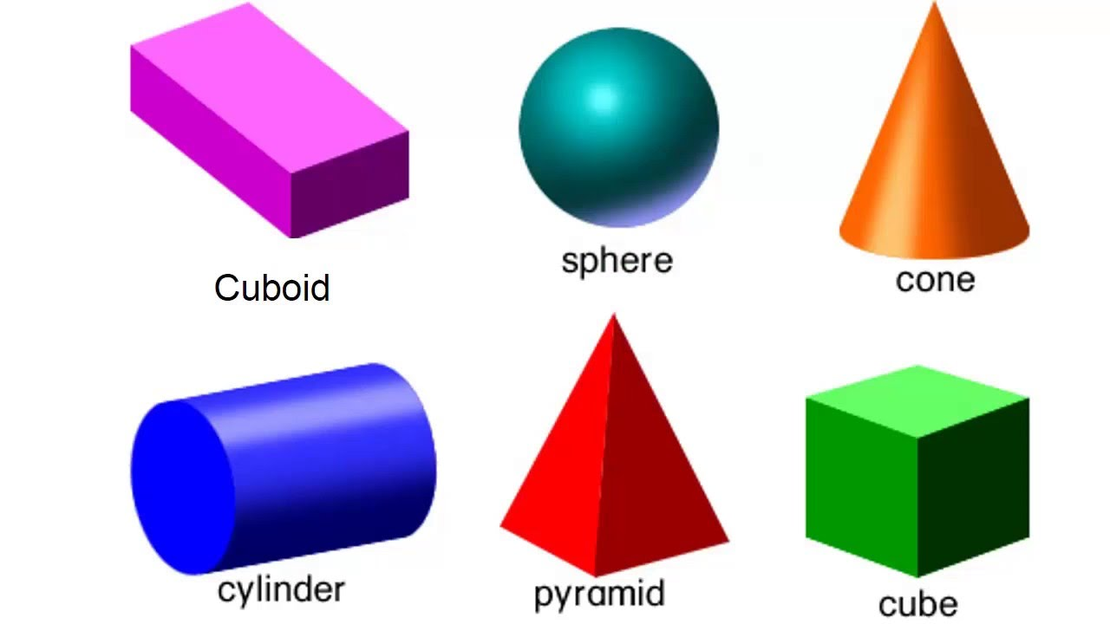

Phase 4 – Phoneme Frame – 1 phoneme sound = 1 box
e.g. t/e/n/t (but ‘th’ fits into 1 box because - 2 letters (th) make 1 sound > th/a/n/k)
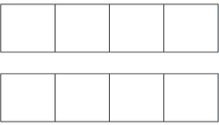

Phase 4 – pictures to write in phoneme frames
(gift, hand, pond, hump, wind, tent, sink, nest, milk)

